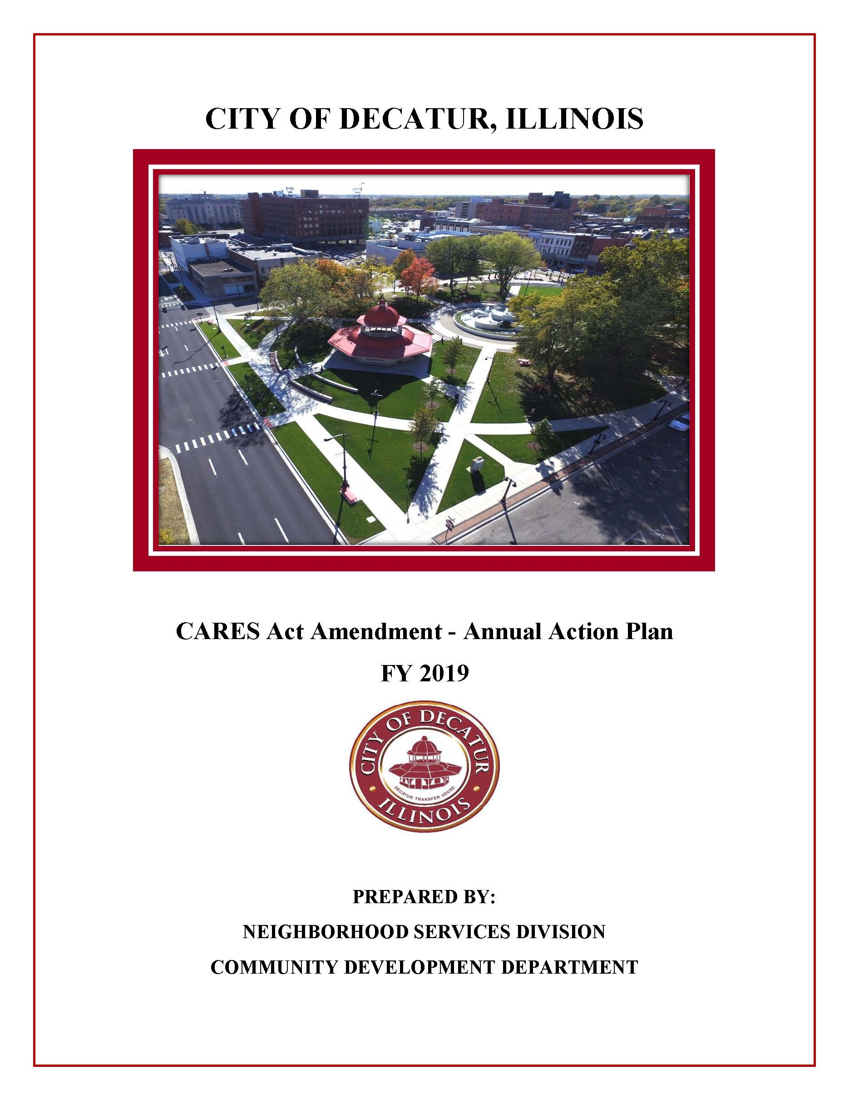

The 1st amendment to the FY2019 was to add CDBG Cares Act funds known as CDBG-CV. A revision to the amendment was completed to add the CDBG-CV3 funds, resulting in combined funding from the CARES Act in the amount of $1,292,894.00. A third revision was made in May, 2023 which established programming for the special CDBG appropriations. At this time, the City of Decatur is proposing Substantial Amendments to the FY 2019 Annual Action Plan for the City of Decatur’s Community Development Block Grant CARES Act Program to make revisions to the programming and funding allocations.

Executive Summary

AP-05 Executive Summary - 24 CFR 91.200(c), 91.220(b)
1. Introduction
This section presents the amendment to Fiscal Year 2019 Annual Action Plan. 2019 is the fifth year of the Consolidated Plan FY2015-2019. This spring, the City was provided an opportunity by the Department of Housing and Urban Development (HUD) to access CDBG-CV funding, in the amount of $834,287, under the CARES ACT. A second allocation, known as CDBG-CV3, was provided in the amount of $458,607. The total funding under the CARES Act is $1,292,894. The CARES ACT funds are to address the preventing, preparing for or responding to the COVID-19 Pandemic. The pandemic creates a variety of problems for the residents and businesses in this country. Social distancing rules were established. The restriction or closure of "non-essential" businesses occurred. Air and ground travel were reduced. Due to reduced services and sales, tax revenue became less. These actions resulted in an economic downturn.
The federal government passed the Coronavirus Aid, Relief, and Economic Security Act (CARES ACT) to be used to address needs of the citizens. Funding was made available to states, counties, cities, and agencies. CDBG-CV funds were identified for the City of Decatur. The CDBG-CV funds may not be a duplicate funding source for an activity. A variety of projects may address the community's COVID-19 effects and needs. It may be said COVID-19 has had a disproportionate impact in certain communities. Those hardest hit can't afford yet another crisis. The funding may help provide a safety net for individuals and families. Projects may include housing related activities, public services, public facilities, economic development, and CARES Act administration/planning. The CDBG-CV and CDBG-CV3 funds must also address the national objectives: address urgent community need, benefit low- and moderate-income residents, and address the elimination of slum and blight.
The City's 2019 allocation was $1,411,581 in Community Development Block Grant (CDBG) funds and $425,163 in HOME Investment Partnership Program (HOME) funds. The CDBG and HOME funding are used to support activities which benefit very low, low, and moderate-income persons and low-moderate income areas. The CDBG and HOME funds will be used in conjunction with program income, carryover funds, and other funding sources to complete programs and projects to further the goals and objectives of the Consolidated Plan.
The 2019 Annual Action Plan presented the City's strategy for use of the entitlement funding allocation during Fiscal Year 2019 to meet the objectives outlined in the Consolidated Plan for housing, homelessness, special needs, public services, economic development, public improvements, and neighborhood revitalization. The information was presented in narrative and table form. Finally, the 2019 Action Plan states the manner in which the City intends to address other areas covered in the Consolidated Plan including barriers to affordable housing, coordination of resources, and program monitoring.
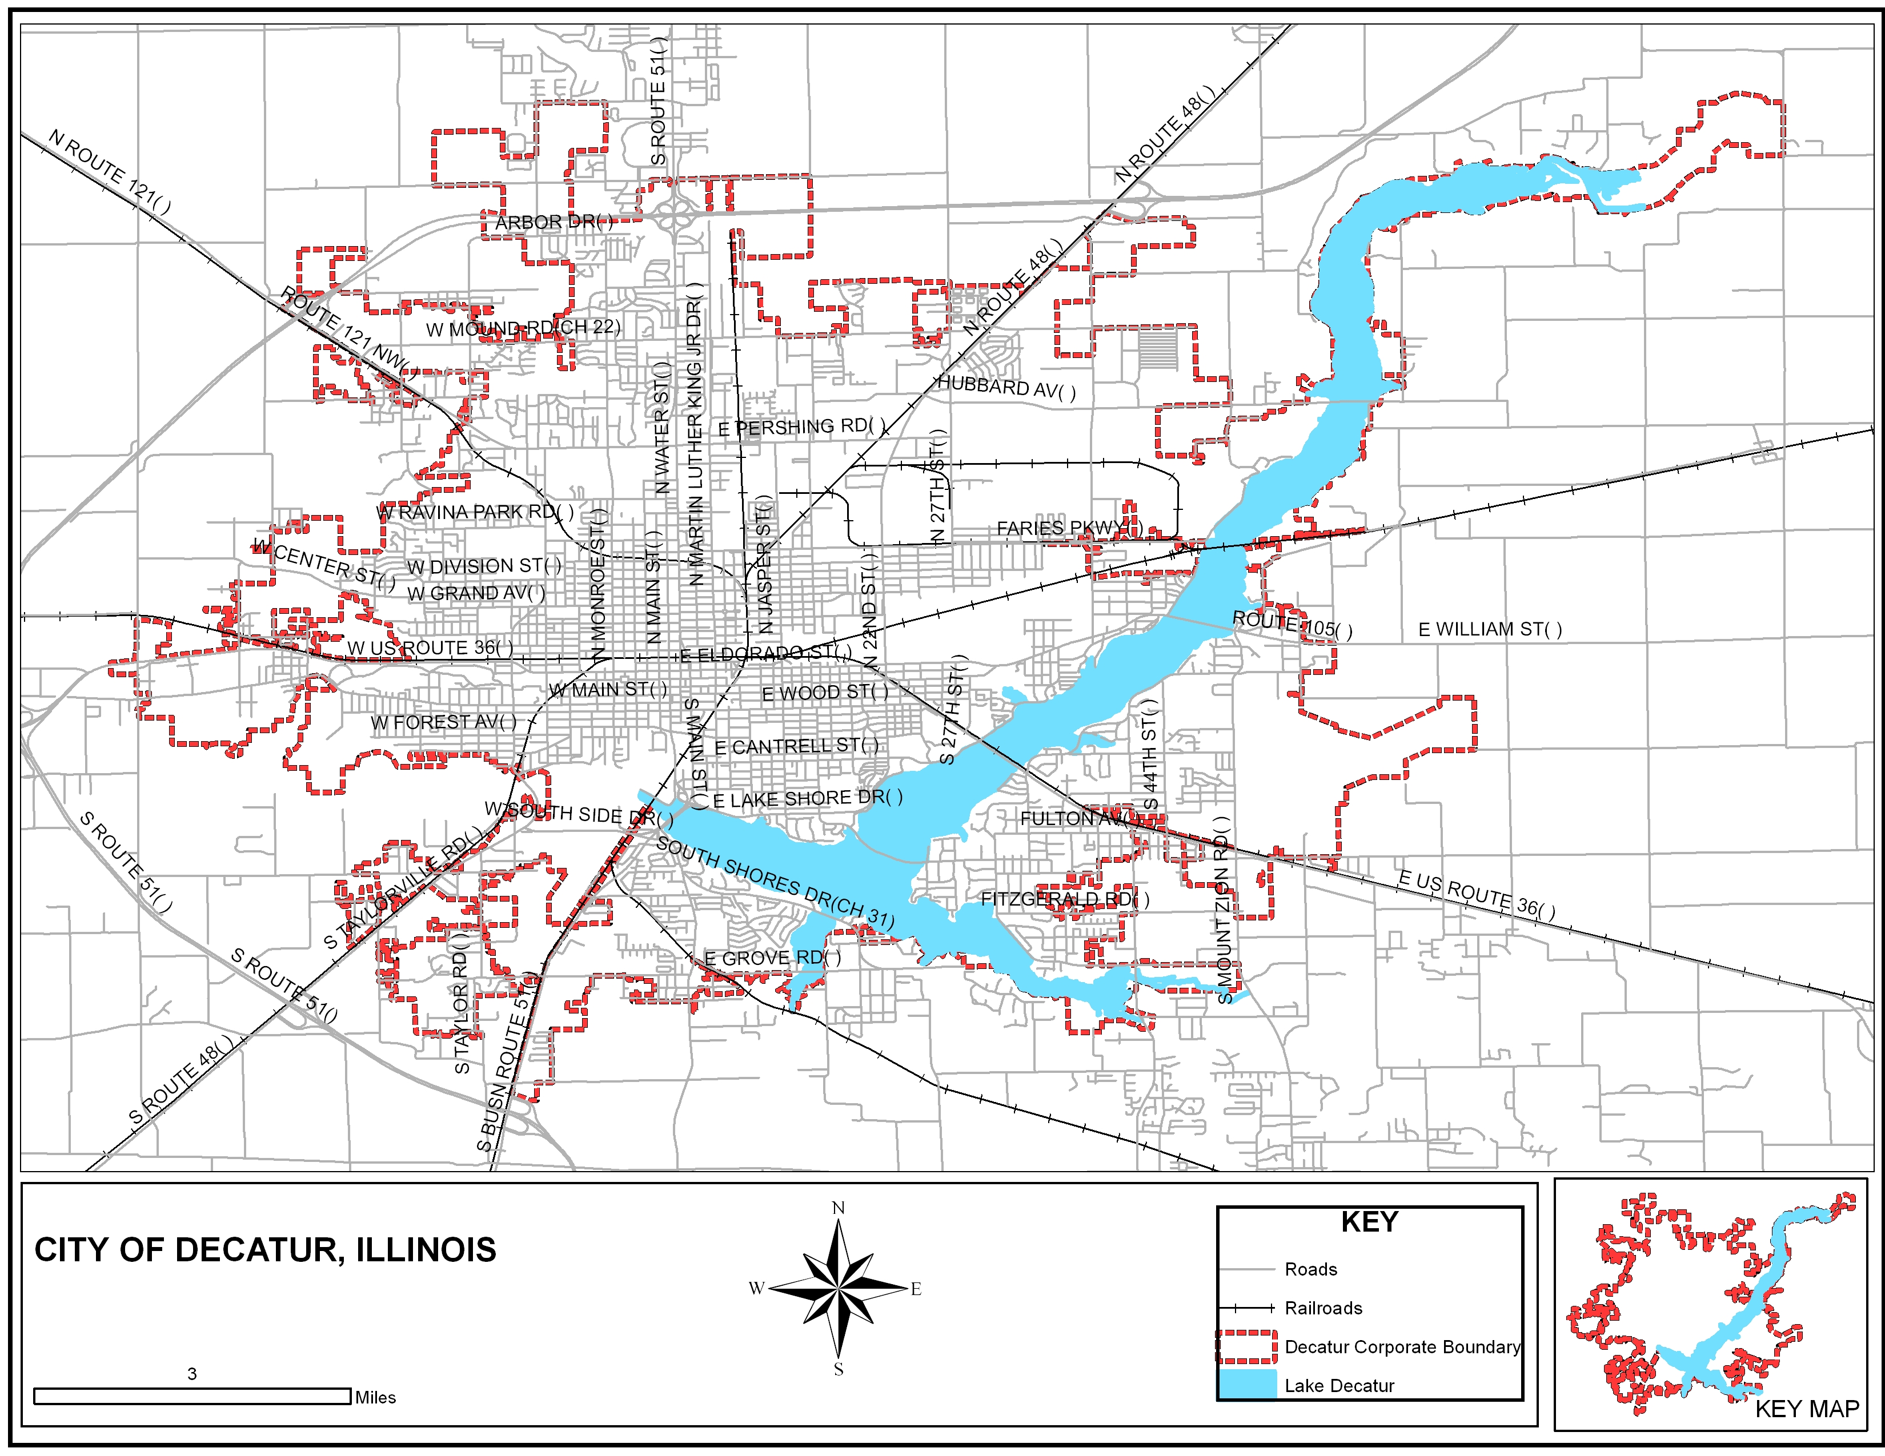
City of Decatur
2. Summarize the objectives and outcomes identified in the Plan
This could be a restatement of items or a table listed elsewhere in the plan or a reference to another location. It may also contain any essential items from the housing and homeless needs assessment, the housing market analysis or the strategic plan.
The City’s 2019 plan addresses objectives that: assist low income families with housing rehabilitation which will address code issues, energy efficiency, accessibility, emergency assistance to enable families to remain in their homes, financial assistance to first time homebuyers, improve the living environment through housing code enforcement and spot demolition, and provide expanded educational/job training opportunities. The expected outcomes will be decent, safe, sanitary, and affordable housing, improve the quality of the living environment, and increase economic opportunity. The additional CDBG-CV3 and CDBG-CV funds will support the urgent needs created by COVID-19. The community has seen many areas which have been impacted by COVID-19: housing, services, employment, and organization staffing. Without the resources, the community cannot address essential needs. Funds have been identified for potential public service activities which provide education for future employment and training programs related to COVID-19. The normal allocation of CDBG and HOME Residential Rehabilitation Programs are handled in a lottery process whether the program is city-wide or targeted. Low income residents complete a form which provides contact information, location of the home, and requested housing assistance. Residents drop the form in a "Lottery Box". Names are periodically drawn. Homeowners are contacted. Appointments are scheduled for homeowners to apply for assistance. Due to COVID-19, the process has changed slightly where intake is initially handled by phone and documentation may be supplied through fax and/or e-mail. Great effort is made to protect the resident and the staff with the goal to address the residents' needs. With limited staffing, both CDBG-CV3 and CDBG-CV funds may be sub-grant the funds to qualified and financially responsible entities which demonstrate the capacity for the delivery of the programs in a timely manner. City staff will still be responsible for monitoring and reporting for the purposes of compliance and timeliness to address the community's COVID-19 needs and HUD compliance.
When public service funding is identified, a notice is provided to the public through various sources: media releases, the City of Decatur web, agency meetings, and mailings. An example: Education and Employment Training program has typically been handled through a notice of funds available to address the community need for adult education and employment preparedness. Informational classes are held for potential recipients. The class identifies the regulations, policy, and procedures associated with the program. The agencies are provided information on how the agency is scored, what attachments are required and a deadline for applications. Applications are reviewed and scored. Recommendations for funding are directed to the Decatur City Council. Under the CDBG grant, public service dollars are limited. The CARES Act provides flexibility in the funding of public service projects. The CARES Act has eliminated the cap on public service for the CDBG-CV and CDBG-CV3 funds.

3. Evaluation of past performance
This is an evaluation of past performance that helped lead the grantee to choose its goals or projects.
The Consolidated Plan identified various goals. A number of the goals were satisfied yet other goals were unmet. Some of the challenges which have limited the ability to meet goals included reduction in funding, loss of staff at various agencies as well as the City, and the COVID-19 pandemic. Some of the success was achieved in the public service funding of education and training outcomes and rehabilitation of homeowner occupied properties. Educational sessions were provided in the fall of 2018 for potential homeowners, current homeowners, tenants and landlords. Although the outcomes were positive, efforts to provide session in the 2019 fiscal year were put on hold due to COVID-19.
Due to a shortfall in general fund budget, the City continues to look for other funding sources. The City of Decatur received funding from the Illinois Housing Development Authority (IDHA) to remove unsafe structures. The City has been approved for additional funding to address the cost of clean-up/maintenance for vacant properties or potentially demolition. The City was awarded $470,000 for the Single-Family Rehabilitation to primarily address rehabilitation and roofs for qualified homeowners und IDHA rules. Regarding economic development efforts, investments continue. Over the last several years, the investment has exceeded more than $200 million. The investment results in new jobs and improved quality of life. The new lakeshore water park was expected to be complete and open in the summer of 2019. However, weather and COVID-19 pandemic has halted the use. Beginning in the fall of 2017, residents were invited to participate in community meetings for the development of a Community Revitalization Plan. The public was updated on the revitalization efforts in May. The Howard G. Buffett Foundation agreed to provide a significant investment of $1 million to support the neighborhood redevelopment portion of the revitalization effort. Recently, the foundation has identified another $1 million for the redevelopment effort. The Buffett Foundation is funding $30 million to build a "Community Care Campus" in the Wabash Crossing neighborhood. The campus will include a detox and residential rehabilitation facility, outpatient treatment center plus transitional housing facility. Baby Talk, an early child development agency, will be relocated to the campus. The facility includes an exercise facility, fitness center, movie theater, outdoor walking path, and space for adult education. This campus is expected to have 200 workers with an economic impact of $13.7 million. April 4, 2019 the Howard Buffett Foundation announced a new gift of $25 million to support Baby Talk and Decatur Macon County Opportunity Corporation. This provides low-income households with a "one-stop" solution to access job training, employment readiness, utility assistance, homeless services, senior services, weatherization assistance, health care, substance abuse treatment, parent training, GED classes, alternative education for mother, fatherhood programming, and early childhood education. This holistic approach creates a wrap-around system of support and care. The construction of the new facilities is underway.

4. Summary of Citizen Participation Process and consultation process
Summary from citizen participation section of plan.
The City of Decatur provides residents the opportunity to share their opinions on the needs and priorities through public discussion, phone communication, fax, letters, surveys or e-mails. The City Council Study Session July 13, 2020 discussed the CARES Act Amendment for the CDBG-CV funding. The CARES Act public meeting for the CDBG-CV funds was held Thursday, July 16, 2020, 1:00 p.m. Residents were provided an opportunity to openly ask questions regarding the proposed 2019 Amendments to the Annual Action Plan and Consolidated Plan. A second meeting was held October 23, 2020 at 1:30 p.m. to discuss the needs and uses for the CDBG-CV 3 funding. Residents and agencies were provided an opportunity to respond or comment by e-mail to ActionPlan@decaturil.gov, by phone to (217) 424-2864 or (217) 424-2777, or by mail to the Neighborhood Services Division, 1 Gary K. Anderson Plaza, Decatur, Illinois. Comments were taken through October 30, 2020. One resident expressed a need to support small business.
A third Public Hearing was on March 14, 2023 to present the proposed third amendment to the FY 2019 Annual Action Plan and to allow for public comment. The 30-day comment period commenced on February 22, 2023 and ended on March 24, 2023.
A fourth Public Hearing was held on _______ to present the proposed fourth amendment to the FY 2019 Annual Action Plan and to allow for public comment. The 30-day comment period commenced on ___________ and ended on __________.
Copies of the draft FY 2019 City of Decatur Annual Action Plan CDBG-CV Amendment 3 were made available for viewing by the public at the following locations:
Decatur Public Library, 130 N. Franklin Street, Decatur, IL 62523
City of Decatur, Department of Community Development, 3rd Floor, #1 Gary K. Anderson Plaza, Decatur, IL. 62523
The documents will also be available at the City of Decatur's website: www.decaturil.gov.
5. Summary of public comments
This could be a brief narrative summary or reference an attached document from the Citizen Participation section of the Con Plan.
The comments were allowed to be submitted by e-mail, letters, phone calls, or at the October 23, 2020 public meeting. Public input at the July 13, 2020 Study Session identified a high need for COVID-19 funding related to services for residents and small businesses. The City continues to participate in a variety of organizational meetings in the community. By use of staff's notes and the organizations' minutes, staff documents services and the participation assessment of community needs. Since November 2017, the City has held a number of public meetings and council study sessions to secure residents' comments on revitalization. As identified in the public meetings held for the Consolidated Plan and the Action Plans, the Neighborhood Revitalization Planning input includes discussion on education, employment, job training, economic development, removal of unsafe structures, safe and affordable housing, crime, and public improvements, such as streets and sidewalks. The Neighborhood Revitalization assumptions could be: Neighborhoods are revitalized with an appropriate blending of human and social services, rehabilitation of housing, infrastructure and other facilities, plus the general uplift of the area's economy. Potentially, the City could serve as guide and facilitator for the stimulation of market forces whenever possible, in addition to partnerships with community development entities, private donors and neighborhood organizations or associations. Each neighborhood is unique and will require different solutions, partners and strategies. It will not be possible to revitalize all neighborhoods at once. The input from the community meetings could be organized into three categories: 1) Neighborhood Regeneration, Support, and Sustainability, 2) Economic and Residential Development, Wellness and Vitality, and 3) local government regulations and relations.
In 2018 and 2019, the City organized eight City-wide clean-up initiatives in which residents could bring non-electronic items and dispose of them at no charge. In 2020, the City planned to provide four more City-wide Clean-up initiatives for residents. Due to COVID-19, the first clean-up event was cancelled. The second, third, and fourth Clean-up Initiatives were successful held. A fourth clean-up was held on October 24, 2020.
The City of Decatur also implemented a Local Motor Fuel Tax (LMFT) a few years ago. The LMFT will be used to address the streets in the worse condition in the community over the next 7 years. Due to the decline of fuel, the LMFT has declined and reduces the funding available for the street improvements. The Howard Buffet Foundation has generous pledged funds for the Revitalization effort.

6. Summary of comments or views not accepted and the reasons for not accepting them
Each resident and organization are entitled to provide input. The goal is to improve the community as a whole through program purposed project implementation based on the community need. During the public meetingthere were no comments made.
7. Summary
The City of Decatur strives to improve the community and the residents' quality of life. The City continues to encourage residents to participate in the discussions and development of the plans, any future amendments to the plans, and the future annual performance report. Residents are encouraged to participate at the community-wide and neighborhood levels. The City continues to address those unmet needs through collaboration with other organizations. Decatur, in conjunction with the community partners, has made the most of the limited resources available. The City will continue the partnerships where meaningful changes will occur to improve the lives of our residents. The following attached information identifies cost burden for owners and renters, housing problems, and severe housing problems. Information regarding population decline has been included. Loss of residents has added to the vacancy issue.
The City of Decatur's Citizen Participation Plan identifies a substantial change as: changes in the use of funds from one Consolidated Plan objective to another; a 38% increase or decrease of funds to any eligible funded activity; changes to carry out an activity using funds from any program covered by the Consolidated Plan which was not previously described in the Action Plan; plus changes of the purpose, scope, location, or beneficiaries of an activity. The Citizen Participation Plan provides flexibility to adjust funding to accommodate increases or decreases in the budget and urgent need. This provides for a faster delivery of programs and activities to serve residents.
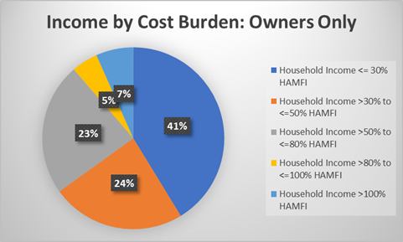
Income by Cost Burden: Owners
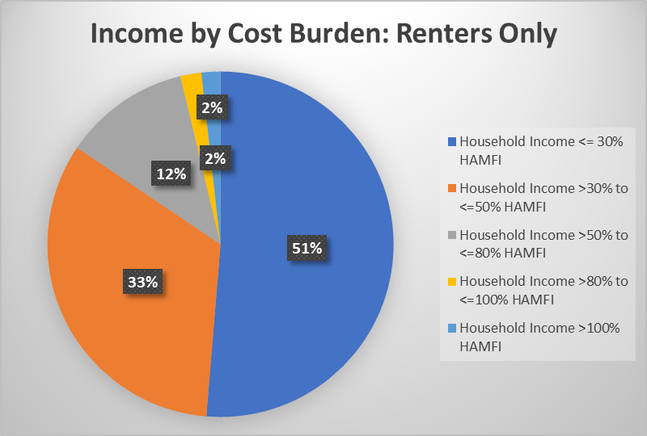
Income by Cost Burden: Renters
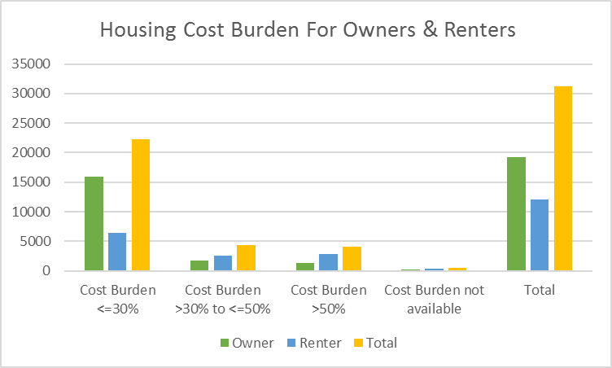
Cost Burden Owner vs. Renter
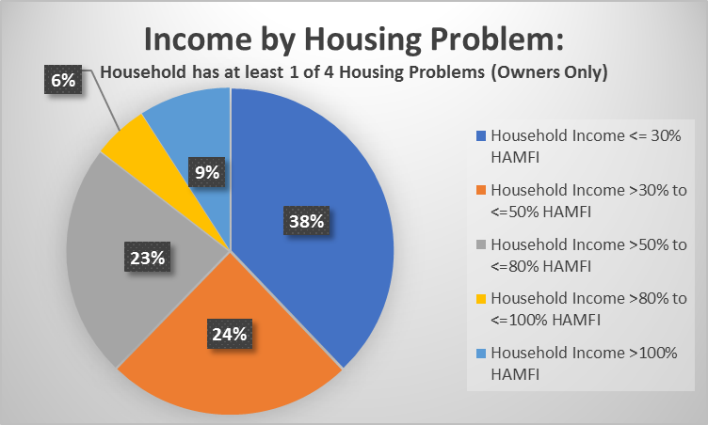
Income by Housing Problem: Owners
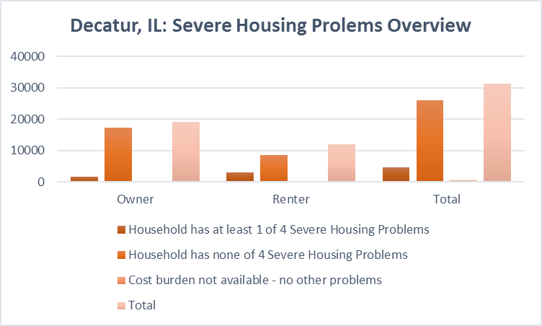
Severe Housing Problems Overview
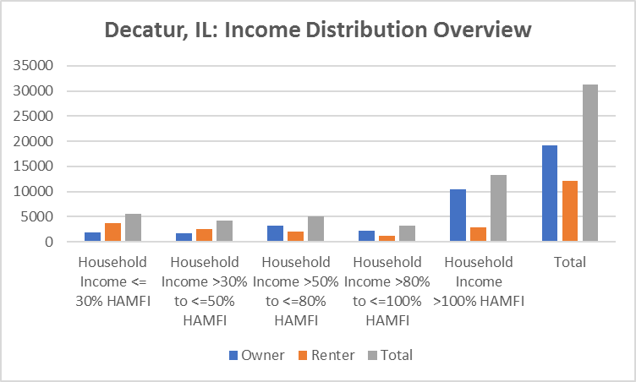
Income Distribution Overview: Decatur
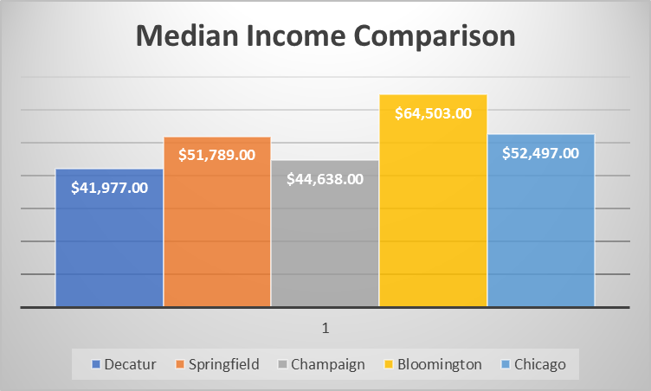
Income Comparison for Central Illinois
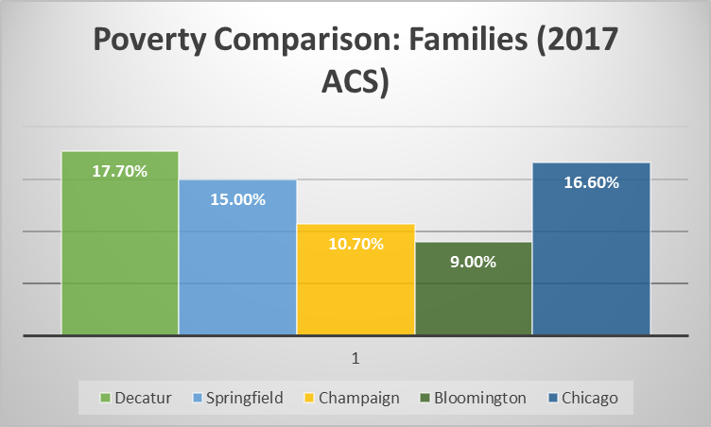
Families in Poverty Comparison for Central IL
Year | Population | Year Range | % Change
1970 | 90,705 | 1970-1980 | 3.7%
1980 | 94,081 | 1980-1990 | -10.8%
1990 | 83,885 | 1990-2000 | -2.4%
2000 | 81,860 | 2000-2003 | -3.3%
2010 | 76,122 | 2003-2005 | -9.7%
2017 ACS | 73,505 | 1970-2017 | -18.9%
Table 1 - Total Population Decline 1970-2017

PR-05 Lead & Responsible Agencies – 91.200(b)
1. Agency/entity responsible for preparing/administering the Consolidated Plan
Describe the agency/entity responsible for preparing the Consolidated Plan and those responsible for administration of each grant program and funding source.
Agency Role | Name | Department/Agency

CDBG Administrator | DECATUR | City of Decatur / Neighborhood Revitalization Div
HOME Administrator | DECATUR | City of Decatur / Neighborhood Revitalization Div
Table 2 – Responsible Agencies

Narrative (optional)
The City of Decatur Neighborhood Services Division is the lead and responsible agency for the development, amendment, and execution of the Consolidated Plan and the Annual Action Plans. This division is also responsible for the Consolidated Annual Performance Evaluation Report (CAPER). Copies of the Action Plan and Consolidated Annual Performance Evaluation Report are available for the public at the following locations:
Decatur Public Library, 130 N. Franklin Street, Decatur, IL 62523
City of Decatur, Department of Community Development, 3rd Floor, #1 Gary K. Anderson Plaza, Decatur, IL. 62523
The documents will also be available at the City of Decatur's website: www.decaturil.gov.

Consolidated Plan Public Contact Information
Richelle L. Dunbar, Neighborhood Services Manager
City of Decatur-Neighborhood Revitalization Division
1 Gary K. Anderson Plaza
Decatur, IL 62523
rdunbar@decaturil.gov
217-424-2864

AP-10 Consultation – 91.100, 91.200(b), 91.215(l)
1. Introduction
The City of Decatur staff participates in a variety of meetings through positions on Boards or as members. Active involvement in a variety of groups, allow staff the opportunity to gather information through meetings and correspondence regarding needs and accomplishments in the community. Examples: Decatur Macon County Homeless Council (Continuum of Care), Decatur Community Partnership (DCP), Decatur Macon County Opportunity Corporation (DMCOC), Heritage Behavioral Health, Decatur Job Council (DJC) and other agencies which includes county and local agencies and government bodies.
The City of Decatur reached out to the residents and agencies through neighborhood meetings, surveys, and correspondence. Community input for the 2019 Action Plan official comment period was May 30th through June 28th, 2019. Surveys were available for residents, non-profits, and businesses to complete and return to the Neighborhood Services Division. Comments were taken by mail, e-mail, or by phone.
- During the COVID-19 pandemic, the City of Decatur and the partners of the Continuum of CARE (CoC) have been watching and monitoring the impact on the residents’ ability to afford housing and/or to remain in their housing units. It is difficult to provide a prediction of the impact of people on the edge of homelessness. Various agencies within the community have received COVID-19 funding from the state and federal government. The CoC and/or a CoC sub- committee meets weekly to discuss the challenges as well as the funding sources being made available for agencies.

Provide a concise summary of the jurisdiction’s activities to enhance coordination between public and assisted housing providers and private and governmental health, mental health and service agencies (91.215(l))
The CoC rolled out coordinated entry and a new position was created. The agencies use general questionnaires through HMIS (Homeless Management Information System) that may be filled out and used to refer any homeless or housed individual with needs to the agency which can assist them. This position has knowledge about all local agencies, their availability and resources. This position spends a day at each shelter and uses Mondays to "hit the streets" to find unsheltered individuals. The 2019 Point in Time (PIT) identified 169 homeless individuals in Decatur, an increase of 9 since the 2018 PIT. The unsheltered homeless individuals were 11 (down 10 from in 2018). Emergency shelters had 117 people. While 41 individuals were in transitional housing. The decrease could be attributed to the CHAT (Continuum Homeless Action Team) team's work.
The City of Decatur is an active member of Decatur Community Partnership (DCP). DCP is committed to promoting collaborative programming among community organizations and individuals. DCP encourages the integration of services to effectively improve the quality of life and health of the residents. Members of the organization include but are not limited to: Decatur Housing Authority, Department of Corrections, Macon County Health Department (MCHD), United Way, State's Attorney Office, Decatur Scovill Zoo, Community Home Environment Learning Project (CHELP), Main Street Church of The Living God, University of Illinois Extension, Richland Community College, City of Decatur, and community volunteers. DCP meets quarterly to monitor the progress of the DCP programs, the expenditures, and to discuss community needs/issues which arise or change.
DCP receives funding through various grants. The Strategic Prevention Framework (SPF) Grant is one grant where the organization's staff works diligently with a Drug-Free Community Coalition to build infrastructure necessary for effective and sustainable prevention. The effectiveness begins with a clear understanding of community needs. DCP works with the local schools for participation in the Illinois Youth Survey to identify these needs. The STOP Act project is a program created to strengthen community collaboration and empower the community to implement strategies for preventing and reducing alcohol use among youth. One component of this program is a partnership with law enforcement to conduct alcohol compliance checks with assistance from youth buyers. Another STOP grant component is the "Underage Drinking Prevention Task Force". The group meets quarterly to take a deeper look at the issue of underage drinking and brainstorm solutions to combat the issue. Project "Sticker Shock" is another tool used during the Alcohol Awareness Month and throughout the year to deter adults 21 and over from purchasing alcohol for minors.

Describe coordination with the Continuum of Care and efforts to address the needs of homeless persons (particularly chronically homeless individuals and families, families with children, veterans, and unaccompanied youth) and persons at risk of homelessness.
The City of Decatur is a member of the Governing Board - Decatur Macon County Homeless Council Continuum of Care (CoC). The CoC and the City have been working together to serve the homeless since 1994. The Homeless Council Continuum of Care diligently works to meet the needs of homeless individuals and families. This partnership and collaborative programs are funded through grants from the U.S. Department of Housing (HUD) and the Illinois Department of Human Services (IDHS). Dove, Inc. is the lead organization with fifteen (15) partner members: Dove, Inc., the City of Decatur-Neighborhood Services Division, Decatur Housing Authority (DHA), Decatur-Macon County Opportunities Corporation (DMCOC), the Community Investment Corporation of Decatur (CICD), Heritage Behavioral Health Center (Heritage), Supportive Services for Veterans Families (SSVF), Salvation Army, Baby Talk, Crossing Healthcare, Millikin University, Macon Piatt Regional Office on Education, Decatur Public Schools District 61, God's Shelter of Love, and Good Samaritan Inn.
The City of Decatur developed a "Ten Year Plan to End Chronic Homelessness" in 2010. Periodically, a "Working Group" met to identify and address the changing environment. The City of Decatur hopes to update the document to reflect the changes in needs, housing, and services.
CHAT was developed in July 2015. This team emerged out of the COC Governing Board as a way to address the high rate of chronic homelessness. The team includes members from area homeless service providers including Heritage Behavioral Health Center, Oasis, Salvation Army, and the Coalition for Veteran's Concerns. The goal of CHAT is to identify and house as many chronically homeless individuals, veterans, children, and families as quickly as possible. The creation of CHAT has allowed providers working directly with homeless person to "wrap" themselves around the individuals, veterans and families to understand their unique needs. Providers work with homeless individuals to fast-track them through the CoC provider. Dove-Homeward Bound, by completing paperwork and connecting the individuals, veterans, children or families directly to Homeward Bound to ensure they are on the list for housing and that priority is given due to the chronic status. The formal coordinated entry policy for Macon County CoC was adopted in January 2018. Within the COC, the Homeless Advisory Council meets regularly to discuss programs, services, community resources as well as any particular needs/barriers for individuals, veterans, and families who are at risk for homelessness. There are more than 75 providers that participate in this formal meeting with ongoing collaboration outside of the meeting. This collaboration goes on daily.
There is a large movement to bring community stakeholders together to improve all areas of the Decatur community including education, social service, health care, and economic development (employment training, job creation, as well as business development).

Describe consultation with the Continuum(s) of Care that serves the jurisdiction's area in determining how to allocate ESG funds, develop performance standards for and evaluate outcomes of projects and activities assisted by ESG funds, and develop funding, policies and procedures for the operation and administration of HMIS
The City of Decatur is a partner on the CoC and monthly engages in consultation with formal CoC Governing Board meetings where all the partners are present. With the assistance of a consultant, the Governing Board as well as identified community stakeholders developed standards related to the evaluation of project and activity outcomes assisted by ESG. Currently, the Salvation Army receives the ESG funds from the State of Illinois, Illinois Department of Human Services (IDHS). This City has ongoing communication and consultation monthly with the CoC as a member of the Governing Board regarding the allocation of ESG funds as well as the development of performance standards and evaluative outcomes. The City works with the CoC in identifying, developing and securing funding for homeless services.
Homeward Bound administers the policies and procedures for the operation and administration of HMIS. Homeward Bound, in collaboration with the City and other partners, is actively working to enhance HMIS utilization by providing information and training to providers not yet engaged in utilization. Continuing education related to the benefits to provide and ultimately, individuals served as they get housing and supportive services, is a priority for the CoC moving forward.
The CoC coordinates efforts and resources for the annual CoC application.

2. Describe Agencies, groups, organizations and others who participated in the process and describe the jurisdiction’s consultations with housing, social service agencies and other entities

Table 3 – Agencies, groups, organizations who participated
1 | Agency/Group/Organization | Dove, Inc.
 | Agency/Group/Organization Type | Services - Housing  Services-Victims of Domestic Violence  Services-homeless
 | What section of the Plan was addressed by Consultation? | Homeless Needs - Chronically homeless  Homeless Needs - Families with children  Homelessness Needs - Veterans  Homelessness Needs - Unaccompanied youth  Homelessness Strategy
 | Briefly describe how the Agency/Group/Organization was consulted. What are the anticipated outcomes of the consultation or areas for improved coordination? | Consultation was through group meetings where services and housing needs for homeless individuals were discussed. Discussion included overall collaboration and planning. The goal is to reduce homelessness as well as taking steps to ultimately end homeless. Discussions cover HMIS, Point In Time (PIT) study, data collection, and usage. Through continuous communication with the organization, the Consolidated Plan and Actions Plans capture/identify the needs. This opens the line of communication and documentation. The City of Decatur is able to provide the agency a Certification of Consistency when needed for various grant applications. The City will continue to work with Dove, Inc. and other homeless providers through the Governing Board, Continuum of Care, etc.
2 | Agency/Group/Organization | Millikin University
 | Agency/Group/Organization Type | Education-University
 | What section of the Plan was addressed by Consultation? | Homeless Needs - Chronically homeless  Homeless Needs - Families with children  Homelessness Needs - Veterans  Homelessness Needs - Unaccompanied youth  Service Learning Education
 | Briefly describe how the Agency/Group/Organization was consulted. What are the anticipated outcomes of the consultation or areas for improved coordination? | Millikin University (MU) provides higher education. The university staff and students are actively involved in the community through a variety of ways. MU students and staff have worked and continue to work with the housing organizations, mental health organizations, DHA, the City of Decatur, and others. Dove, Inc. has MU interns involved with the homeless monitoring. In 2019, MU had 22 students engaged in the Point In time effort for the City of Decatur. MU requires the freshman students to take Service Learning through the MU Career Center. Students are involved for approximately 10 hours or more. Students and staff are involved in a wide range of areas which encompasses the various education areas. Those areas include but are not limited to human services, education, free income tax service for low income, natural sciences, astronomy, non-profit fund raising, counseling/mental health, art/art therapy and more. The university, along with Good Samaritan, Aldi, Central Illinois Food Bank, and the Decatur Public School Foundation provides a backpack program, for three consecutive years. Millikin University has partnered with Dennis Elementary School (pre-K-8th grade). Dennis Lab School now focuses on Project-Based Learning. The partnership of Dennis School and Millikin University has launched an International Host Family Program. The partnership provides a supportive home away from home for the international students. This provides the international student an opportunity to experience family life in Decatur, Illinois. This provides an opportunity to make new friends while contributing to a greater understanding of other cultures by educating Americans about the student's home country. MU manages the Macon County Teen Court Program. The program, called the Teen Justice Program, moves from a government-based setting to a university setting. It is a collaborative experience with community partners, faculty, and students majoring in Criminal Justice. The program is a voluntary diversion program for first-time offenders between the ages of 9 and 17 who have been arrested for criminal offenses in Macon County. Rather than deciding guilt or innocence, program volunteers create service plans for the participants within a three-month period. If the participants are successful and complete the program, no charges are ever filed in the criminal courts. MU has actively worked with the CoC on a 5 Year Strategic Planning. MU worked with and trained the CoC partners and service providers on the Model of Change and de-escalation. The Model of Change is the method on how the clients are worked with. The Institute for Science Entrepreneurship (ISE), engages community stakeholders with presentations 8 times a year at Millikin University. ISE just completed its 6th year of engagement in the community. The ISE has had over 1000 attendees for their presentation. This provides another example of community networking. MU's Human Service major Internship Program works with local social service providers each fall and spring semester.
3 | Agency/Group/Organization | Economic Development Corporation of Decatur and Macon County
 | Agency/Group/Organization Type | Regional organization  Business Leaders
 | What section of the Plan was addressed by Consultation? | Economic Development
 | Briefly describe how the Agency/Group/Organization was consulted. What are the anticipated outcomes of the consultation or areas for improved coordination? | The president of the Economic Development Corporation of Decatur-Macon County identified job training for adults (18+) should be a priority in 2019. In addition to job training, it is encouraged to support the development of small businesses. In regard to housing, EDC identified there a new need for new-modern apartments and/or leased housing opportunities. There should be an increase in market rate leased housing in the city.
4 | Agency/Group/Organization | Macon County Health Department
 | Agency/Group/Organization Type | Services-Health  Other government - County
 | What section of the Plan was addressed by Consultation? | Food Safety, Dental, etc.
 | Briefly describe how the Agency/Group/Organization was consulted. What are the anticipated outcomes of the consultation or areas for improved coordination? | The point of contact for this organization was the Executive Director. This organization provides a variety of services as well as case management. The organization is an active participant on committees and coalitions, such as: Decatur Community Partnership, Teen Health Coalition, Opioid Coalition, the Greater Decatur Chamber of Commerce, Obesity Prevention Coalition, and much more. The organization promotes good health in a number of ways, from education, case management, and delivery of needed services. This organization provides dental services, partners with SIU physician services, and senior services. MCHD works with seniors through case management to help keep senior independent in their home as well as provide the "Macon Memories Cafe". Seniors may participate in a Medication Management Program which provides bi-weekly visits. This organization implemented the Teen Pregnancy and Sexually Transmitted Infection Prevention Grant. Their pilot program, Let's Talk Teen Health, was provided at both Decatur high schools, serving 19 students over 28 sessions. MCHD provides immunization clinics and influenza clinics throughout the year. This organization has a Lead Grant from the Illinois Department of Public Health (IDPH) to follow families with a child with a confirmed lead test > 10. This organization inspection the facilities which provide food.
5 | Agency/Group/Organization | Project READ
 | Agency/Group/Organization Type | Services-Education
 | What section of the Plan was addressed by Consultation? | Adult Literacy & Case Management
 | Briefly describe how the Agency/Group/Organization was consulted. What are the anticipated outcomes of the consultation or areas for improved coordination? | Project Read Plus (PRP)/RCC, formerly known as Project Read/RCC, executive director stated the organization provides services for adults with literacy needs as a stepping-stone for employment opportunities. PRP mission is to help adults improve their reading and math skills through free one-on-one tutoring with trained volunteers. The average competency of participants is below a 5th grade level. Approximately 97% of the current participants live in poverty. With increased math and reading skills, students may qualify for job training, earn a high school equivalency diploma, pass classes, obtain certificates and degrees that lead to employment. The outcomes improve not only their lives but the lives of the children/grandchildren. The organization partners with the Decatur Public Library, Workforce Development, Dove, Inc., Baby Talk, Crossing Healthcare, Adult Ed and Family literacy programs, Homeward Bound, Good Samaritan Inn, Education Coalition, Decatur Jobs Council, Old King Orchard's Community Center, Millikin University, Macon County Jail, GEO Reentry Program, Illinois State University, Salvation Army, and more.
6 | Agency/Group/Organization | Decatur Housing Authority
 | Agency/Group/Organization Type | Housing  PHA
 | What section of the Plan was addressed by Consultation? | Self Sufficiency and Section 3
 | Briefly describe how the Agency/Group/Organization was consulted. What are the anticipated outcomes of the consultation or areas for improved coordination? | The Executive Director shared the mission is to provide and maintain quality affordable housing with access to community resources for low to moderate income families and individuals. DHA specifically desires to increase the availability of decent, safe, and affordable housing, improve the quality of housing in the community, increase assisted housing choices and ensure equal opportunity in housing for all. DHA manages public housing inventory which consists of 10 zero-bedroom units, 293 one-bedroom units, 71 two-bedroom units, 68 three-bedroom units, 21 four-bedroom units and 15 five-bedroom units. As of May 2019, DHA managed units were 98% occupied with a wait list of approximately 560 households. DHA has identified the need to increase the overall quality and availability of affordable housing. DHA will solicit development partners for construction of new affordable housing which may be partially supported by Project Based Housing Choice Vouchers. The organization is committed to securing additional funds, new collaborators to increase services to elderly and disabled residents. DHA continues to use Capital Fund Program funds to improve existing properties.
7 | Agency/Group/Organization | Decatur Community Partnership
 | Agency/Group/Organization Type | Services
 | What section of the Plan was addressed by Consultation? | Collaborative programming amoung organizations and individuals to encourage integration of services.
 | Briefly describe how the Agency/Group/Organization was consulted. What are the anticipated outcomes of the consultation or areas for improved coordination? | The Decatur Community Partnership (DCP)is a mix of organizations, such as: Decatur Housing Authority, Illinois Department of Corrections, Macon County Health Department, State's Attorney Office, Decatur Park District/Scovill Zoo, Main Street Church of the Living God, University of Illinois Extension, St. Mary's Hospital, Macon-Piatt Regional Office of Education, Heritage Behavioral health Center, and the City of Decatur. DCP discusses community needs/issues which arise or change. DCP receives funding for substance abuse prevention the Illinois Department of Human Services, foundations and some local funds through the Macon County State's attorney's Office Adult Division Program. The Executive Director provides "Youth Prevention Education" in local schools, Alcohol Awareness, and more.
8 | Agency/Group/Organization | Decatur Jobs Council
 | Agency/Group/Organization Type | Services-Education  Services-Employment  Group of agencies, educational institutions, and government
 | What section of the Plan was addressed by Consultation? | Employment, Training, Case Management
 | Briefly describe how the Agency/Group/Organization was consulted. What are the anticipated outcomes of the consultation or areas for improved coordination? | The chair collaboration of agencies. As a whole, the group advocates and leads efforts to eliminate barriers to employment through Networking and communication to stakeholders, including resources and best practices in barrier identification, assessment and resolution.
9 | Agency/Group/Organization | Macon County Mental Health Board
 | Agency/Group/Organization Type | Services - Housing  Disabilities
 | What section of the Plan was addressed by Consultation? | Housing Need Assessment  Homelessness Strategy  Homeless Special Needs
 | Briefly describe how the Agency/Group/Organization was consulted. What are the anticipated outcomes of the consultation or areas for improved coordination? | The Macon County Mental Health Board (MCMHB)provided a survey to the community for input. MCMHB held a community wide meeting to discuss the challenges and potential needs. In addition to the public meeting, staff met with a representative to discuss future special-needs housing and services. Factors discussed included the aging housing, the aging of caretakers, and the necessity for future services for the special-needs residents. It was determined additional information on the special needs population should be secured to determine how much of a need will exist in the next five to ten years.
10 | Agency/Group/Organization | Community Investment Corporation of Decatur, Inc.
 | Agency/Group/Organization Type | Housing  Services - Housing
 | What section of the Plan was addressed by Consultation? | Economic Development
 | Briefly describe how the Agency/Group/Organization was consulted. What are the anticipated outcomes of the consultation or areas for improved coordination? | This organization's staff was involved in group discussion regarding the need residents' need for housing counseling and housing assistance. Discussion was held with CICD, Inc. regarding small business needs.

Identify any Agency Types not consulted and provide rationale for not consulting
A variety of organizations and economic development organizations were provided an opportunity to provide input through conversations, surveys, and electronic communication. Unfortunately, a number of organizations were not available to provide input.

Other local/regional/state/federal planning efforts considered when preparing the Plan
Name of Plan | Lead Organization | How do the goals of your Strategic Plan overlap with the goals of each plan?
Continuum of Care | DOVE, Inc. | The goals of the plan overlap with the strategy and goals of the Continuum of Care. The City is an active partner on the CoC working to end homelessness. The City and the CoC work actively to ensure a fluid plan of action to address homelessness.
Table 4 – Other local / regional / federal planning efforts

Narrative (optional)
N/A

AP-12 Participation – 91.105, 91.200(c)
1. Summary of citizen participation process/Efforts made to broaden citizen participation
Summarize citizen participation process and how it impacted goal-setting

The Citizen Participation process was handled through group meetings or Zoom meetings, one-on-one discussions, and public meetings. Information was provided through press releases, news articles, e-mail, and the City's website. Due to COVID-19, the most effective method for input is a mix of all.

Citizen Participation Outreach
Sort  Order | Mode of Outreach | Target of Outreach | Summary of  response/attendance |  | Summary of  comments received |  | Summary of  comments not accepted and reasons | URL (If applicable)
1 | Public Meeting | Non-targeted/broad community | The meeting was held 7/16/20, at 1:00 p.m., in the City Council Chambers. The doors open 15 minutes prior to the meeting. |  | N/A. |  | Due to the lack of comments or questions, a summary is not applicable.
2 | Newspaper Ad | Non-targeted/broad community | Attendance was not required. |  | No comments were received. |  | Not applicable.
3 | teleconference/meetings/Zoom meetings | Non-targeted/broad community | Responses will be provided upon the close of the comment period. |  | No comments at this time. |  | Not applicable at this time.
4 | Public Meeting | Non-targeted/broad community | The meeting, in the Council Chamber, was held October 23, 2020, at 1:30 p.m. Doors were open 15 minutes prior to the meeting. The meeting was available on the government Channel 18 and was recorded as well. The information was available on the City's website, in two local newspapers, and shared by press release. |  | One comment was received by phone. The caller was in support of assistance for small businesses. |  | Not applicable at this time.
5 | Public Meeting | Non-targeted/broad community | The following meetings were held:  -9/29/2022:  First Focus Group Meeting 3:00p -4:30p  First Steering Committee Meeting 5:30p -7:00p  -10/20/2022  Jasper Street Fest – Kickoff  -11/17/2022  Steering Committee Meeting  -2/16/2023  Steering Committee Meeting 5:30p – 7:00p |  | Public comments reflected the following needs:  - gathering spaces for families including pocket parks and recreational spaces  - Placemaking including improved look and public Art  - Attraction of new residents  - supportive services for new businesses  - cleanup of neighborhoods to rid the blight  - traffic reconfiguration to slow traffic and make it safer |  | Not applicable at this time.
6 | Public Meeting | Non-targeted/broad community | The meeting, in the Council Chamber, was held March 14, 2023, at 12:00 p.m. (noon) Doors were open 15 minutes prior to the meeting. The information was available on the City's website, in a local newspapers, and shared by press release. |  | No comments at this time. |  | Not applicable at this time.
7 | Public Meeting | Non-targeted/board community | The meeting, in the Council Chamber, was held _____ Doors were open 15 minutes prior to the meeting. Theinformation was available on the City’s website, in a local newspaper and shared by press release. | No comments at this time. | Not applicable at this time.
Table 5 – Citizen Participation Outreach

Expected Resources

AP-15 Expected Resources – 91.220(c)(1,2)
Introduction
Each year, the Federal government identifies an annual allocation for the Community Development Block Grant (CDBG) funds and the HOME Investment Partnership (HOME) funds. The 2019 CDBG Allocation is $1,411,581. The HOME 2019 is $425,163. *Please note: HOME program income (PI) is estimated for 2019 as $30,000. The HOME 2019 allocated funds were distributed: 10% to Administration, 15% to CHDO Reserve, Residential Rehabilitation, and Homebuyer Program. The 90% of the HOME PI will be directed to residential rehabilitation projects and 10% of the HOME PI may be directed to administration. The CDBG funding will be directed to administration, code enforcement, emergency program, and rehabilitation. For 2019, no CDBG program income is predicted.
The CARES Act funding total is $1,292,894.00. The funding is available for prevention, preparation for, and response to the coronavirus (COVID-19). The 2019 Action Plan is being amended to incorporate the additional funds called "CDBG-CV3" in the amount of $458,607. The original amendment for the $834,287 of CDBG-CV funds were amended in July 2020. The Citizen participation Plan was updated in July 2020 due to COVID. At this time, the City of Decatur is proposing Substantial Amendments to the FY 2019 Annual Action Plan for the City of Decatur’s Community Development Block Grant CARES Act Program. The amendment’s purpose is to make revisions to the programming and funding allocations.

Anticipated Resources
Program | Source of Funds | Uses of Funds | Expected Amount Available Year 1 |  |  |  | Expected Amount Available Remainder of ConPlan  $ | Narrative Description
 |  |  | Annual Allocation: $ | Program Income: $ | Prior Year Resources: $ | Total:  $
CDBG | public - federal | Acquisition  Admin and Planning  Economic Development  Housing  Public Improvements  Public Services | 1,411,581 | 0 | 0 | 1,411,581 | 1,411,581 | This is the fifth and final year of the 5 Year Consolidated Plan 2015-2019
HOME | public - federal | Acquisition  Homebuyer assistance  Homeowner rehab  Multifamily rental new construction  Multifamily rental rehab  New construction for ownership  TBRA | 425,163 | 30,000 | 0 | 455,163 | 455,163 | This is the fifth and final year of the 5 Year Consolidated Plan.
Other | public - federal | Admin and Planning  Economic Development  Housing  Public Services  Other | 1,292,894 | 0 | 0 | 1,292,894 | 0 | The CDBG-CV/CDBG-CV3 funds are to prevent, prepare for, and respond to the pandemic.
Table 6 - Expected Resources – Priority Table

Explain how federal funds will leverage those additional resources (private, state and local funds), including a description of how matching requirements will be satisfied
Leveraging of funds may occur from a variety of sources. Leveraging may be satisfied by a variety of ways: the owner's private funds, financial institutions, Federal Home Loan Bank (FHLB), foundations as well as other government (local, city, county, and state) funds.
In the HOME Investment Partnership Program, the City has been required to provide a match of 12.5% for every HOME dollar expended. For example: The PR33 report for 2018 identified $167,673.45 were disbursed which required a match of $15,966.93 or 15.%. The City of Decatur has banked over $4 million in excess match from previous years. The HOME Match "Bank" was used for projects such as residential rehabilitation in 2018 and will be utilized for projects in 2019. Match is not required for some areas, such as: administration and CHDO projects. Match may be private funds and donation as long as the funds are non-federal dollars. The Neighborhood Services Division identified potential funding sources from foundations and other public funds in 2018. The Economic and Community Development Department-Neighborhood Services Division continues to submit applications for potential outside funding to address the needs in the community.
Match is not required under the CDBG program. Due to a delay of 2018 funding and temporary staff shortage, a number of projects and programs, such as: infrastructure, rehabilitation, and public services activities were late to be initiated in the calendar year 2019. Some of the projects are multi-year projects. The City of Decatur is utilizing local funds, state Motor Fuel Tax funds, user fees, and foundation funds to address several needs in the community.

If appropriate, describe publicly owned land or property located within the jurisdiction that may be used to address the needs identified in the plan
At this time, no vacant land has been identified for the development of affordable housing or public facility to benefit very low, low, and moderate people. Therefore, no vacant land was purchased with CDBG or HOME program funds in 2018, 2019 nor will be acquired in the calendar year 2020.

Discussion
Previously demolished property was removed to eliminate the slum and blight in the neighborhoods. The City of Decatur's, Economic and Community Development, applied and received grant funds, in the amount of $125,000 from the Illinois Housing Development Authority (IHDA) for demolition of unsafe, vacant structures. The City applied for additional IHDA grant funds in the amount of $75,000. The City was awarded $55,000 to use for clean-up and maintenance of blighted property. The Neighborhood Inspection Division, a division of the Community Development Department, will administer the IHDA grant funds. The Neighborhood Services Division continuously looks for funding opportunities to address the community's needs, such as: aging housing stock, safe and affordable housing, environmental improvements, etc.

Annual Goals and Objectives

AP-20 Annual Goals and Objectives
Goals Summary Information
Sort Order | Goal Name | Start Year | End Year | Category | Geographic Area | Needs Addressed | Funding | Goal Outcome Indicator
Table 7 – Goals Summary

Goal Descriptions

1 | Goal Name | PY19-OH: Low-income homeowner rehabilitation
 | Goal Description | This activity is designed to improve single-family, owner-occupied residential units. The activity may address code, incipient codes, lead/environmental issues, accessibility, and/or energy conservation. Funding made available to address the code issues through both CDBG and HOME funds.  Under the CARES Act, Waivers and Flexibilities were provided to the Participating Jurisdiction (PJ). The City, a PJ, presented a waiver request regarding the CHDO funds and re-use of those funds for another eligible HOME activity, such as rehabilitation. This waiver covers the HOME funding years of 2017, 2018, 2019, and 2020. The City has not had a certified CHDO since 2016. The effects of COVID-19 reduced the household income creating financial challenges for homeowners to maintain the home to code.  Through the second 2019 Action Plan Amendment, the CDBG funds set-aside to assist homeowner occupants with code improvements will be reduced. $25,000 of the funds will be re-allocated to assist homeowner occupants with urgent housing which are less than $5,000. Example: A C O leaking furnace or a furnace with a cracked heat exchanger will be replaced with an efficient furnace.
2 | Goal Name | PY-19 CD: Increase code enforcement of properties
 | Goal Description | This funding provides for the code enforcement in low- and moderate-income areas. The Neighborhood Service Officers (NSOs) identify housing code violations as well as trash and debris violations. The NSOs also identify weed issues in the area and work with the property owners to correct the problems. Code enforcement applies to both investor rental properties and homeowner properties.  The activity may focus more on buildings and structures and address community cleanliness, public advertisement displays, garage sales, lawn care, environmental concerns (such as abandoned tires), and the condition of the motor vehicles on the streets.
3 | Goal Name | PY19-CD 1: Continue demo of unsafe structures
 | Goal Description | This activity will address infeasible, unsafe, uninhabitable buildings in the community. This activity will remove the hazardous property or condition while following procedures to which are environmentally sound.
4 | Goal Name | PY19-PS: Education/training-Job skill development
 | Goal Description | The community continues to identify and support the need for adult education, to prepare the resident for training and employment. This need was identified in both the 2010-2014 Consolidated Plan and the 2015-2019 Consolidated Plan. Currently, two non-profits are funded under this project activity with prior year funds. This funding will provide for additional adult education, training, and case management.
5 | Goal Name | PY19-PA: Planning/General Administration
 | Goal Description | Costs associated the oversight, citizen participation and education, project monitoring, and management of the federal funds for both CDBG and HOME. When HOME Program Income exists, 10% of the HOME Program Income (PI) will be marked for HOME administration. With PI projected at $30,000, $3,000 would be used for HOME Administration. Please note prior year HOME administrative funds have not been depleted and will be utilized prior to the 2019 funds.
6 | Goal Name | PY19-OH 1: Housing Rehabilitation Delivery
 | Goal Description | This activity provides for housing rehabilitation delivery. This activity covers the costs of staff and contractual services from participant intake to determine eligibility, descriptions of work to be performed as required under the codes, monitoring of the rehabilitation, and close-out of each rehabilitation activity.
7 | Goal Name | PY19-OH 2: Emergency low-income homeowner assist.
 | Goal Description | The program is designed to address all emergency issues in the home which are life-threatening. The program corrects the emergency problem (urgent need). The program provides funds to correct electrical hazards, replace the heating mechanical system in the winter, etc. The program provides a grant up to $5,000.00. The assistance is provided to homeowner-occupied single-family units. A homeowner may receive assistance only once in a fiscal year. The program is expected to assist a minimum of 10 housing units.  Due to the first amendment of the 2019 AP, 2019 reprogrammed administrative funds will provide an additional $25,000 to the Emergency Program. A minimum of 5 homes may be assisted with the additional funding. Under the second amendment, an additional $25,000 was added to the Emergency Program to another 5 homes. Potentially, a minimum of 20 homeowner occupied homes may receive assistance through the Emergency Program.  The increase in costs of material and labor, the increase costs in daily living expenses, and reduced income have resulted in higher need to assist low and moderate income homeowners.
8 | Goal Name | PY19-OH 3: First-time homebuyer fin. assistance
 | Goal Description | This program is designed to provide assistance to first time homebuyers. The program focuses on owner-occupied purchases in the City of Decatur. The program requires participants to attend Homebuyer Education classes through a HUD-approved housing council agency. In January 2018, City of Decatur partnered with Community Investment Corporation of Decatur, Inc. (CICD) to provide an education class at no cost to the participants. Additional education classes were held in October for homeowners.  The program is expected to assist a minimum of 5 households.
9 | Goal Name | PY19-OH 4:Low-income affordable home ownership
 | Goal Description | The funds are reserved for Community Housing Development Organizations (CHDO) to renovate an existing housing unit or construct a new affordable housing unit. The CHDO would correct any code deficiencies, incorporate or improve energy conservation, and may provide homeowner accessibility improvements. The housing unit would be sold to a qualified low-income household. Based on the HOME allocations, 2019 CHDO set aside was $63,774.45 for new construction of an affordable homeowner unit. Currently, the City of Decatur does not have a certified CHDO with a project. Currently, the City does not have CHDO operating funds available.  Under the CARES ACT, the HOME Program was allowed to change funding to address high needs due to COVID-19. Safe and affordable housing is difficult when maintain the household income is diminished as a result of COVID-19. Despite repeated efforts by HUD, HUD Technical Assistance, and the CITY, the community remains without a CHDO.  Under the CARES Act, Waivers and Flexibilities were provided to the Participating Jurisdiction (PJ). The City, a PJ, presented a waiver request regarding the CHDO funds and re-use of those funds for another eligible HOME activity, such as rehabilitation. This waiver covers the HOME funding years of 2017, 2018, 2019, and 2020. The City has not had a certified CHDO since 2016. The effects of COVID-19 reduced the household income creating financial challenges for homeowners to maintain the home to code.
10 | Goal Name | PY19-ED: Economic Development
 | Goal Description | This goal was identified for the repayment of the Section 108 Loan for the Wabash Crossing note series.
11 | Goal Name | PY 2019 CDBG-CV Small business public service
 | Goal Description | Provide assistance to small businesses impacted by the effects of COVID-19. Assistance may be provided to new and existing businesses to address the COVID-19 issues.
12 | Goal Name | PY 2019 CDBG-CV Public Service
 | Goal Description | Provide assistance to qualified organizations with capacity to qualify and assist those impacted by the effects of COVID-19. Assistance will be provided to the organizations to address the COVID-19 issues. The funding will not be used to duplicate or replace another funding sources. Example of assistance for low-income households/individuals affected by COVID-19 may be but not limited to: short-term rent, mortgage, or utility assistance, delivery of meals to quarantined individuals or services for vulnerable individuals which need to social distance, job training for those to expand the pool of health care workers, etc. Assistance should be delivered in a timely manner to meet the needs of the community.
13 | Goal Name | PY 2019 CDBG-CV Administration
 | Goal Description | CDBG-CV Administrative activities related to federal compliance and sub-grantee management, including, but not limited to, technical assistance, monitoring and program review and reporting. Program monitoring for the CDBG-CV funding will occur more frequently than once a year. Program monitoring may initially occur upon the expenditure of 25% and/or 50% of the funds to ensure compliance, capacity, and delivery of the urgent need of the programs. This monitoring is in addition to the required monthly sub-recipient reports for expenditures and beneficiaries.
14 | Goal Name | PY 2019 CDBG-CV Realignment and Reconfiguration of Garfield Park
 | Goal Description | The City of Decatur will provide CDBG-CV funding, in partnership with the Decatur Park District, as a matching grant to reconfigure the existing Garfield Park into a more user friendly and updated park that the community will utilize. The CDBG-CV funding will provide suitable outdoor fitness and social space where insufficient facilities are available to support social distancing guidance. This will be an integral part of the much larger catalyst project which seeks to redevelop the Garfield School site, to include high-quality residential uses (Independent Senior Living Apartments), other mixed-income housing units and a re-configured park, grow the population of the area and support nearby businesses by adding “purchase power” in the Neighborhood United neighborhood.
15 | Goal Name | PY 2019 CDBG-CV Community Center property re-purposing, leveraging an Urban Agriculture Project Phase I
 | Goal Description | The City of Decatur will provide CDBG-CV funding to help with the purchase of equipment and installation of a recreation site. This area will allow children in LMI area to have access to soccer, football, and baseball activities within walking distance of their homes. COVID-19 has had and will continue to have a profound effect on mental and physical health of people of all ages. Providing such amenities will provide suitable outdoor fitness, and social space where insufficient facilities are available to support social distancing guidance. Coupled with this recreation site, the City, through other funding, will also help create an urban agriculture project and work life skills program. Through a local organization, residents will learn how to grow and sell food.
16 | Goal Name | PY 2019 CDBG-CV Community Center property re-purposing, leveraging an Urban Agriculture Project Phase 2
 | Goal Description | The City of Decatur will provide CDBG-CV funding to help with the purchase of equipment and installation of a recreation site. This area will allow children in LMI area to have access to soccer, football, and baseball activities within walking distance of their homes. COVID-19 has had and will continue to have a profound effect on mental and physical health of people of all ages. Providing such amenities will provide suitable outdoor fitness, and social space where insufficient facilities are available to support social distancing guidance. Coupled with this recreation site, the City, through other funding, will also help create an urban agriculture project and work life skills program. Through a local organization, residents will learn how to grow and sell food.
17 | Goal Name | PY 2019 CDBG-CV Acquisition of childcare facility/campus realignment
 | Goal Description | The City of Decatur will acquire a property in order to reconstruct a daycare along a busy corridor within the City’s urban core. This reconstruction will increase the capacity and availability of daycare services serving low/mod areas. This will also improve indoor air quality and ventilation to improve public health and prevent the spread of coronavirus by replacing the HVAC and other building systems. The City will also realign the nearby area by creating an interactive, and vibrant placemaking opportunity which will include an outdoor multi-use venue that can be used as a food truck court, neighborhood entertainment center, kid-friendly facilities, calming place that will allow individuals the opportunity to sit, drink a cup of coffee, enjoy free Wi-Fi services while reading a book or enjoying lunch outside.
18 | Goal Name | PY 2019 CDBG-CV Improvement of childcare facility/campus realignment
 | Goal Description | The City of Decatur will reconstruct a daycare along a busy corridor within the City’s urban core. This reconstruction will increase the capacity and availability of daycare services serving low/mod areas. This will also improve indoor air quality and ventilation to improve public health and prevent the spread of coronavirus by replacing the HVAC and other building systems. The City will also realign the nearby area by creating an interactive, and vibrant placemaking opportunity which will include an outdoor multi-use venue that can be used as a food truck court, neighborhood entertainment center, kid-friendly facilities, calming place that will allow individuals the opportunity to sit, drink a cup of coffee, enjoy free Wi-Fi services while reading a book or enjoying lunch outside.
19 | Goal Name | PY 2019 CDBG-CV Acquisition/Improvement for campus realignment/placemaking & parking improvement
 | Goal Description | The City of Decatur will acquire and reconstruct a daycare along a busy corridor within the City’s urban core via goals 17 and 18. This reconstruction will increase the capacity and availability of daycare services serving low/mod areas. This will also improve indoor air quality and ventilation to improve public health and prevent the spread of coronavirus by replacing the HVAC and other building systems. The City will also realign the nearby area by creating an interactive, and vibrant placemaking opportunity which will include an outdoor multi-use venue that can be used as a food truck court, neighborhood entertainment center, kid-friendly facilities, calming place that will allow individuals the opportunity to sit, drink a cup of coffee, enjoy free Wi-Fi services while reading a book or enjoying lunch outside.

Projects

AP-35 Projects – 91.220(d)
Introduction
The Consolidated Plan process identified dangerous, unfit housing stock continues to be a challenge. Homeowners need assistance to save and maintain the housing. As our population ages, seniors are moving into smaller housing, senior housing, or assisted living units. Thus, making more homes available for new home buyers to purchase. Rehabilitation assistance and homebuyer assistance are essential to the livability and affordability of housing in the City. Qualifying homebuyers continues to be a challenge. Aging infrastructure and the declining property values generate less property taxes which effects the City of Decatur's annual revenues. The Local Motor Fuel Tax (LMFT) is currently funding improvements. The City completed more than $4.2 million in improvements with local street repairs. This work will continue for at least the next 7 years. In addition to identified streets and sidewalk improvements, the City has identified upwards of $70 million in sanitary sewer problems and deferred maintenance. Sanitary and storm sewer upgrades continued in 2018 and were funded through a storm water utility use fee. Education of low/moderate income adult residents and hard to employ residents opens training and employment opportunities for those residents. CDBG funding will be provided in 2019 for this public service. Sub-grantees are currently funded with prior year funds. With more residents employed, employed residents may spend and invest additional dollars back in the community. Housing units in the "Regeneration" Area are older homes where code improvements are costly especially when addressing lead. The outcomes for 2019 are expected to be substantial less due to the increase cost of renovations. The City is constantly looking for additional grant or foundation dollars to assist with rehabilitation improvements for homeowners. The estimated outcomes for emergency rehabilitation are expected to be approximately 10 while for the CDBG and HOME rehabilitation programs are expected to assist approximately 12 homeowner occupied units. Many of the low-income census tracts are in the Regeneration Area. Code Enforcement identifies housing code/property issues. The Neighborhood Service Officer (NSO) identifies the issues and the homeowners are notified. Some owners are at a loss as to how to proceed to the correct the problem. Some issues may be easy to resolve by the owner-occupied. The NSO may direct the owner-occupant to the Neighborhood Services Division for assistance. Some residents may qualify for emergency rehabilitation assistance while others may qualify for rehabilitation assistance.
The housing programs address the needs for decent, affordable housing for low- and moderate-income households, the barriers to obtaining affordable housing, as well as the preservation and improvement of affordable housing. The programs may create a suitable living environment by addressing conditions that are a threat to the health and safety of the homeowner. The programs may make existing housing accessible to persons with disabilities.
The CDBG public service program provides better access for low-income residents to needed services for education, training, and case management. Coronavirus Aid, Relief, and Economic Security Act (CARES Act), CDBG-CV and CDBG-CV3 funds are to be utilized to prevent, prepare for, or to respond to the COVID-19 Pandemic.

Projects
# | Project Name
1 | 2019 Residential Rehabilitation
2 | 2019 CDBG Emergency Program
3 | 2019 Housing Rehabilitation Delivery Costs
4 | 2019 Code Enforcement
5 | 2019-Public Service: Adult Education, Training, and Case Management
6 | 2019 Demolition
7 | 2019 General Administration
8 | 2019 Section 108 Loan Repayment
9 | 2019 Homebuyer Assistance Program
10 | 2019 CHDO Project
11 | PY 19 CDBG-CV Public Services Small Businesses
12 | PY 19 CDBG-CV Public Services
13 | PY 19 CDBG-CV Administration
14 | PY 2019 CDBG-CV Realignment and Reconfiguration of Garfield Park
15 | PY 2019 CDBG-CV Community Center property re-purposing, leveraging an Urban Agriculture Project Phase I
16 | PY 2019 CDBG-CV Community Center property re-purposing, leveraging an Urban Agriculture Project Phase II
17 | PY 2019 CDBG-CV Acquisition of childcare facility/campus realignment
18 | PY 2019 CDBG-CV Improvement of childcare facility/campus realignment
19
Table 8 - Project Information

Describe the reasons for allocation priorities and any obstacles to addressing underserved needs
Through the Citizen Participation process, the residents and organizations identified the needs and the level of need in the community. The community has seen a decrease in funding in many areas which has affected services, employment, and organization staffing. Without financial resources, the community cannot address all the needs.
Residents may access assistance for the Emergency Program through a first-come first serve process. This program addresses dangerous, life-threatening housing conditions for the homeowner. An Emergency Program example: Cracked heat exchanger on a furnace is leaking carbon monoxide (CO). The furnace would be removed and replaced for the owner-occupied housing unit.
The CDBG and HOME Residential Rehabilitation Program is handled through a lottery process. Low income residents complete a form which provides contact information, location of the home, and requested housing assistance. Residents may drop their form in a "Lottery Box". The residents are given approximately six weeks to deposit a form in the lottery box. Names are periodically drawn from the box. Homeowners are contacted. Appointments are scheduled for homeowners to apply for assistance.
The public service program is handled through a notice of funds available to address the community need of adult education, training, and employment preparedness. An informational class is held for potential agencies. The class identifies the regulations, policy, and procedures associated with the program. Agencies are provided information on how the agency will be scored and what information is required. A deadline is provided for applications. Applications are reviewed and scored. Recommendations for funding are directed to the Decatur City Council.

AP-38 Project Summary
Project Summary Information1 | Project Name | 2019 Residential Rehabilitation
 | Target Area | City of Decatur  Regeneration Area
 | Goals Supported | PY19-OH: Low-income homeowner rehabilitation
 | Needs Addressed | Housing
 | Funding | CDBG: $373,976  HOME: $324,330
 | Description | This program will provide home rehabilitation assistance to low income homeowner who are occupants. The rehabilitation program will address code deficiencies. Other items which may be addressed: accessibility, lead, and energy efficient mechanical improvements or replacements. $304,003.88 CDBG funds will be allocated for this activity. $233,555.75 HOME funds are allocated for this project. HOME PI is estimated as $27,000. A minimum of 12 units will be rehabilitated with these funds.
 | Target Date | 10/30/2020
 | Estimate the number and type of families that will benefit from the proposed activities | Estimated 12 households will be provided assistance to rehabilitate their homes.
 | Location Description | The housing assistance is limited to the City of Decatur incorporated area. Priority may be given to homes located in the targeted area.
 | Planned Activities | This program will address code issue in the homes of low/moderate income homeowners.
2 | Project Name | 2019 CDBG Emergency Program
 | Target Area | City of Decatur
 | Goals Supported | PY19-OH 2: Emergency low-income homeowner assist.
 | Needs Addressed | Housing
 | Funding | CDBG: $100,000
 | Description | Funds under this program will be used to assist low income homeowners with emergency repairs to their homes (such as: furnace, electrical, etc.). This program would eliminate a potential life-threatening issue. This program will not address housing maintenance items, such as: roofs, foundation, siding, windows, etc. The housing unit must be structurally sound and occupied by the homeowner. This program is limited to homeowners who occupy a single-family unit.
 | Target Date | 12/31/2020
 | Estimate the number and type of families that will benefit from the proposed activities | The activity is anticipated to assist a minimum of 10 households. With the addition of two amendment of $25,000, a minimum of 10 additonal homeowner-occupied housing units should be assisted.
 | Location Description | This is a city-wide program.
 | Planned Activities | Low income homeowner occupied units will receive assistance to correct the emergency code issue in the home. The grant assistance will be provided once a fiscal year. The total assistance must be less than $5,000 per housing unit.
3 | Project Name | 2019 Housing Rehabilitation Delivery Costs
 | Target Area | City of Decatur
 | Goals Supported | PY19-OH 1: Housing Rehabilitation Delivery
 | Needs Addressed | Housing
 | Funding | CDBG: $96,259
 | Description | The activity provides $96,259 for housing rehabilitation delivery for 2019 funded projects. The activity supports the rehabilitation homeowner occupied residential units in the City. The accomplishment of this goal is reflected in the rehabilitation activity.
 | Target Date | 8/31/2020
 | Estimate the number and type of families that will benefit from the proposed activities | This activity is funded rehabilitation administration. This activity indirectly benefits families. The accomplishments will be reported in the Emergency Program and the Residential Rehabilitation Program.
 | Location Description | N/A
 | Planned Activities | This activity is for the rehabilitation programs.
4 | Project Name | 2019 Code Enforcement
 | Target Area | NEIGHBORHOOD STANDARDS #1 & 2 (CODE ENFORCEMENT)  Regeneration Area
 | Goals Supported | PY-19 CD: Increase code enforcement of properties
 | Needs Addressed | Housing  Economic Development/Funding/Financing  Public Infrastructure/assets
 | Funding | CDBG: $211,301
 | Description | Funding for the Neighborhood Service Officers (NSO) to enforce housing codes within the low/moderate income census tracts/block. The goal is to improve safety and quality of life for residents. This activity will be a tool to help maintain and improve the livability of neighborhoods and slow or eliminate the potential for blighted areas. The NSO may provide direction and/or education for residents regarding code issues.
 | Target Date | 4/30/2020
 | Estimate the number and type of families that will benefit from the proposed activities | This is a low-moderate area benefit.
 | Location Description | Low/Moderate Income census tracts.
 | Planned Activities | The NSO is often the first contact for a homeowner to communicate with regarding housing issues. It is not uncommon for the NSO to direct the homeowner to the Neighborhood Services Division for emergency rehabilitation or residential rehabilitation assistance.
5 | Project Name | 2019-Public Service: Adult Education, Training, and Case Management
 | Target Area | City of Decatur
 | Goals Supported | PY19-PS: Education/training-Job skill development
 | Needs Addressed | Education/training
 | Funding | CDBG: $45,000
 | Description | This project will provide funding for adult education to prepare low income Decatur residents for training and employment opportunities. $45,000 is identified for the 2019 fiscal year.
 | Target Date | 12/31/2022
 | Estimate the number and type of families that will benefit from the proposed activities | The proposed activity will provide education, training, and/or case management to a minimum of 20 low income adult Decatur residents.
 | Location Description | This activity may be city wide.
 | Planned Activities | This is a public activity designed to provide educational opportunities, case management, and skill development for low income adult Decatur residents. The education/training opportunities may open doors for the participants to move forward and improve their employment opportunities.
6 | Project Name | 2019 Demolition
 | Target Area | NEIGHBORHOOD STANDARDS #1 & 2 (CODE ENFORCEMENT)  Regeneration Area
 | Goals Supported | PY19-CD 1: Continue demo of unsafe structures
 | Needs Addressed | Housing  Economic Development/Funding/Financing
 | Funding | CDBG: $200,000
 | Description | This activity would remove or eliminate/demolish the unsafe buildings.
 | Target Date | 12/31/2020
 | Estimate the number and type of families that will benefit from the proposed activities | The spot demolition activity would benefit the neighborhoods where the buildings are located. There would be no direct benefit to a household.
 | Location Description | N/A
 | Planned Activities | Removal of unsafe structures.
7 | Project Name | 2019 General Administration
 | Target Area | City of Decatur
 | Goals Supported | PY19-PA: Planning/General Administration
 | Needs Addressed | Planning and Administration
 | Funding | CDBG: $182,186  HOME: $45,516
 | Description | This activity funds administration, monitoring, reporting, and related management activities for the federally funded programs. The CDBG maximum for administration is 20%. HOME Administration is limited to 10% of each year's allocation and 10% of the program income. $42,516.30 is identified for the 2019 HOME administrative costs. The projected Program Income is $30,000 thus 10% or $3,000 may be available for HOME Administration.
 | Target Date | 5/1/2020
 | Estimate the number and type of families that will benefit from the proposed activities | The activity does not provide benefit to the residents of Decatur.
 | Location Description | N/A
 | Planned Activities | Administrative responsibilities related to the grant funds.
8 | Project Name | 2019 Section 108 Loan Repayment
 | Target Area | City of Decatur
 | Goals Supported | PY19-ED: Economic Development
 | Needs Addressed | Economic Development/Funding/Financing
 | Funding | CDBG: $202,859
 | Description | The funds for this project will be used to repay the Section 108 Loan principal in 2019. This Section 108 Loan funds were originally used for the Wabash Crossing project.
 | Target Date | 4/30/2020
 | Estimate the number and type of families that will benefit from the proposed activities | N/A
 | Location Description | N/A
 | Planned Activities | This activity is a loan repayment only.
9 | Project Name | 2019 Homebuyer Assistance Program
 | Target Area | City of Decatur  Regeneration Area
 | Goals Supported | PY19-OH 3: First-time homebuyer fin. assistance
 | Needs Addressed | Housing
 | Funding | HOME: $85,317
 | Description | This program is designed to provide assistance to first time homebuyers. The program focuses on owner-occupied purchases in the City of Decatur. The program requires participants to participate in Homebuyer Education classes through a HUD-approved housing council agency.
 | Target Date | 5/31/2021
 | Estimate the number and type of families that will benefit from the proposed activities | This program is designed to assist first time homebuyers. This program is limited to buyers who wish to own and occupy the unit. The purchases of the home will be restricted to the incorporated area of Decatur. This program is limited to low income households. The goal is to assist a minimum of six households with the purchase of a home. This program is not designed to refinance a contract for deed purchase or lease to rent purchase.
 | Location Description | The program will operate in the City of Decatur. Target areas include the Regeneration Neighborhoods.
 | Planned Activities | The homebuyers will be required to participate and complete homebuyer counseling. The homes will be inspected for safety and code compliance by city staff. Homebuyers are encouraged to seek home inspections in addition to the code review by city staff. The program is not designed to assist with rehabilitation of the home.
10 | Project Name | 2019 CHDO Project
 | Target Area | City of Decatur  Regeneration Area
 | Goals Supported | PY19-OH 4:Low-income affordable home ownership
 | Needs Addressed | Housing
 | Funding | $0
 | Description | This project would have provided funds to a certified Community Housing Development Organization for the new construction of a residential unit. The residential unit would provide an affordable, safe housing unit. Under the CARES Act, Waivers and Flexibilities were provided to the Participating Jurisdiction (PJ). The City, a PJ, presented a waiver request regarding the CHDO funds and re-use of those funds for another eligible HOME activity, such as rehabilitation. This waiver covers the HOME funding years of 2017, 2018, 2019, and 2020. The City has not had a certified CHDO since 2016. The effects of COVID-19 has reduced the household income creating financial challenges for homeowners to maintain the home to code. CHDO funding for 2017, 2018, and 2019 will be added to the 2017, 2018, and 2019 eligible activity for rehabilitation.
 | Target Date | 5/31/2022
 | Estimate the number and type of families that will benefit from the proposed activities | One household would benefit from the construction of a new safe, affordable unit. The CHDO will be encouraged to develop a unit which is a minimum 3-bedroom, two-bathroom, accessible unit with a garage and parking for another vehicle in the driveway. The CHDO will be required to have pre-qualified potential homeowners.  Please note: Under the CARES Act Flexibility and Waivers for the HOME Program, the funds have been re-assigned to rehabilitation for homeowners.
 | Location Description | The CHDO will be encouraged to develop the unit on a vacant lot in the City.
 | Planned Activities | Construction of one affordable housing unit.
11 | Project Name | PY 19 CDBG-CV Public Services Small Businesses
 | Target Area | City of Decatur
 | Goals Supported | PY 2019 CDBG-CV Small business public service
 | Needs Addressed | Economic Development/Funding/Financing
 | Funding | CDBG-CV/CDBG-CV3: $92,358.12
 | Description | The CDBG-CV funding is for small businesses, which did not receive funding under the SBA Paycheck Protection Program (PPP)or the Economic Injury Disaster Loan Program (EIDL). The PPP provided funds to keep the business viable. In turn, the employees have funds to pay their bills. EIDL provided assistance to businesses for working capital and normal operating expenses. Examples: rent and utilities.
 | Target Date | 12/30/2024
 | Estimate the number and type of families that will benefit from the proposed activities | It is estimated a minimum of 4 small businesses affected by COVID-19 may be assisted.
 | Location Description | Small businesses within the City of Decatur may be assisted.
 | Planned Activities | The assistance be used for burdens/hardships created by the pandemic. This economic development assistance could be used for the retention of employees, rent/assistance, power assistance, business transition to produce prevention COVID-19 items needed due to the COVID-19 pandemic, employee training for production transition, etc. Again, this assistance is provided due to the hardships and challenges created by the pandemic. No entity may receive CDBG-CV funded IF other COVID-19 funded has been received. This assistance may indirectly benefit the low-income employee by providing assistance to the business.
12 | Project Name | PY 19 CDBG-CV Public Services
 | Target Area | City of Decatur
 | Goals Supported | PY 2019 CDBG-CV Public Service
 | Needs Addressed | Housing  Education/training
 | Funding | CDBG-CV/CDBG-CV3: $74,154.41
 | Description | Provide funding to organizations to assist those impacted by the effects of COVID-19. Assistance will be provided to the organizations to address the COVID-19 issues. The funding will not be used to duplicate or replace another funding sources. Example of assistance for low-income households/individuals affected by COVID-19 may be but not limited to: short-term rent, mortgage, or utility assistance, delivery of meals to quarantined individuals or services for vulnerable individuals which need to social distance, job training for those to expand the pool of health care workers, etc. This funding will be utilized for Decatur residents who have been financially impacted by the pandemic. In some public service programs, the assistance may be a tool which allows residents to stay in their home or provides assistance to allow the vulnerable residents (those with health issues and/or over 60) to remain safely in their home.
 | Target Date | 12/30/2024
 | Estimate the number and type of families that will benefit from the proposed activities | It is estimated a minimum of 60 residents/households will be assisted. Those assisted have needs as a result of the COVID-19 pandemic. The pandemic caused hardships through loss of income or reduced income. A variety of needs exist. In some situations, the pandemic caused job loss plus housing and food instabilities.
 | Location Description | City Wide
 | Planned Activities | The activities may include rent assistance, mortgage assistance, and/or utility assistance for those households have been affected by the COVID-19 pandemic. Loss of income or reduction of income has caused instability in the home and the inability to support these basic needs for affordable housing.
13 | Project Name | PY 19 CDBG-CV Administration
 | Target Area | City of Decatur
 | Goals Supported | PY 2019 CDBG-CV Administration
 | Needs Addressed | Planning and Administration
 | Funding | CDBG-CV/CDBG-CV3: $96,381.47
 | Description | CDBG-CV Administrative activities related to federal compliance and sub-grantee management, including, but not limited to, planning, technical assistance, monitoring and program review and reporting under the CARES ACT.
 | Target Date | 12/31/2024
 | Estimate the number and type of families that will benefit from the proposed activities | Not applicable.
 | Location Description | City Wide.
 | Planned Activities | CDBG-CV Administrative activities related to federal compliance and sub-grantee management, including, but not limited to, technical assistance, monitoring and program review and reporting.
14 | Project Name | PY 19 CDBG-CV Realignment and Reconfiguration of Garfield Park
 | Target Area | City of Decatur
 | Goals Supported | Use CDBG-CV funds to meet unfunded, urgent local need
 | Needs Addressed | COVID -19 Response
 | Funding | CDBG-CV/CDBG-CV3: $150,000
 | Description | Meeting an unfunded, urgent local need for increased outdoor recreational facilities that encourage physical distancing for a low- and moderate-income area in order to prevent, prepare for, and respond to coronavirus.
 | Target Date | 9/21/2023
 | Estimate the number and type of families that will benefit from the proposed activities | This is a low-moderate area benefit.
 | Location Description | City Wide.
 | Planned Activities | The City of Decatur will provide CDBG-CV funding, in partnership with the Decatur Park District, as a matching grant to reconfigure the existing Garfield park into a more user friendly and updated park that the community will utilize. The CDBG-CV funding will provide suitable outdoor fitness and social space where insufficient facilities are available to support social distancing guidance. This will be an integral part of the much larger catalyst project which seeks to redevelop the Garfield School site, to include high-quality residential uses (Independent Senior Living Apartments), other mixed-income housing units and a re-configured park, grow the population of the area and support nearby businesses by adding “purchase power” in the Neighborhood United neighborhood.
15 | Project Name | PY 19 CDBG-CV Community Center property re-purposing, leveraging an Urban Agriculture Project Phase I
 | Target Area | City of Decatur
 | Goals Supported | Use CDBG-CV funds to meet unfunded, urgent local need
 | Needs Addressed | COVID -19 Response
 | Funding | CDBG-CV/CDBG-CV3: $200,000
 | Description | Meeting an unfunded, urgent local need for increased outdoor recreational facilities that encourage physical distancing for a low- and moderate-income area in order to prevent, prepare for, and respond to coronavirus.
 | Target Date | 9/21/2023
 | Estimate the number and type of families that will benefit from the proposed activities | This is a low-moderate area benefit.
 | Location Description | City Wide.
 | Planned Activities | The City of Decatur will provide CDBG-CV funding to help with the purchase of equipment and installation of a recreation site. This area will allow children in LMI area to have access to soccer, football and baseball activities within walking distance of their homes. COVID-19 has had and will continue to have a profound effect on mental and physical health of people of all ages. Providing such amenities will provide suitable outdoor fitness, and social space where insufficient facilities are available to support social distancing guidance. Coupled with this recreation site, the City, through other funding, will also help create an urban agriculture project and work life skills program. Through a local organization, residents will learn how to grow and sell food.
16 | Project Name | PY 19 CDBG-CV Community Center property re-purposing, leveraging an Urban Agriculture Project Phase II
 | Target Area | City of Decatur
 | Goals Supported | Use CDBG-CV funds to meet unfunded, urgent local need
 | Needs Addressed | COVID -19 Response
 | Funding | CDBG-CV/CDBG-CV3: $50,000
 | Description | Meeting an unfunded, urgent local need for increased outdoor recreational facilities that encourage physical distancing for a low- and moderate-income area in order to prevent, prepare for, and respond to coronavirus.
 | Target Date | 9/21/2023
 | Estimate the number and type of families that will benefit from the proposed activities | This is a low-moderate area benefit.
 | Location Description | City Wide.
 | Planned Activities | The City of Decatur will provide CDBG-CV funding to help with the purchase of equipment and installation of a recreation site. This area will allow children in LMI area to have access to soccer, football and baseball activities within walking distance of their homes. COVID-19 has had and will continue to have a profound effect on mental and physical health of people of all ages. Providing such amenities will provide suitable outdoor fitness, and social space where insufficient facilities are available to support social distancing guidance. Coupled with this recreation site, the City, through other funding, will also help create an urban agriculture project and work life skills program. Through a local organization, residents will learn how to grow and sell food.
17 | Project Name | PY 2019 CDBG-CV Acquisition of childcare facility/campus realignment
 | Target Area | City of Decatur
 | Goals Supported | Use CDBG-CV funds to assist low and moderate income (LMI) persons, families, or area; meet unfunded, urgent local need
 | Needs Addressed | COVID -19 Response
 | Funding | CDBG-CV/CDBG-CV3: $180,000
 | Description | Meeting an unfunded, urgent local need for increased childcare opportunities for low- and moderate-income persons, families, or area in order to prevent, prepare for, and respond to coronavirus.
 | Target Date | 9/21/2023
 | Estimate the number and type of families that will benefit from the proposed activities | LMH single family homes including female heads of households. 50-75 families.
 | Location Description | City Wide.
 | Planned Activities | The City of Decatur will acquire site in order to construct a daycare along a busy corridor within the City’s urban core. This reconstruction will increase the capacity and availability of daycare services serving low/mod areas. This will also improve indoor air quality and ventilation to improve public health and prevent the spread of coronavirus by replacing the HVAC and other building systems. The City will also realign the nearby area by creating an interactive, and vibrant placemaking opportunity which will include an outdoor multi-use venue that can be used as a food truck court, neighborhood entertainment center, kid-friendly facilities, calming place that will allow individuals the opportunity to sit, drink a cup of coffee, enjoy free Wi-Fi services while reading a book or enjoying lunch outside.
18 | Project Name | PY 2019 CDBG-CV Improvement of childcare facility/campus realignment
 | Target Area | City of Decatur
 | Goals Supported | Use CDBG-CV funds to assist low and moderate income (LMI) persons, families, or area; meet unfunded, urgent local need
 | Needs Addressed | COVID -19 Response
 | Funding | CDBG-CV/CDBG-CV3: $450,000
 | Description | Meeting an unfunded, urgent local need for increased childcare opportunities for low- and moderate-income persons, families, or area in order to prevent, prepare for, and respond to coronavirus.
 | Target Date | 9/21/2023
 | Estimate the number and type of families that will benefit from the proposed activities | LMH single family homes including female heads of households. 50-75 families.
 | Location Description | City Wide.
 | Planned Activities | The City of Decatur will reconstruct a daycare along a busy corridor within the City’s urban core. This reconstruction will increase the capacity and availability of daycare services serving low/mod areas. This will also improve indoor air quality and ventilation to improve public health and prevent the spread of coronavirus by replacing the HVAC and other building systems. The City will also realign the nearby area by creating an interactive, and vibrant placemaking opportunity which will include an outdoor multi-use venue that can be used as a food truck court, neighborhood entertainment center, kid-friendly facilities, calming place that will allow individuals the opportunity to sit, drink a cup of coffee, enjoy free Wi-Fi services while reading a book or enjoying lunch outside.
19 | Project Name
 | Target Area
 | Goals Supported
 | Needs Addressed
 | Funding
 | Description
 | Target Date
 | Estimate the number and type of families that will benefit from the proposed activities
 | Location Description
 | Planned Activities

AP-50 Geographic Distribution – 91.220(f)
Description of the geographic areas of the entitlement (including areas of low-income and minority concentration) where assistance will be directed
Rehabilitation assistance for housing units will be available throughout the community to address the housing needs of low-income homeowners. As funds become available, homebuyer assistance will be available for purchases within the incorporated area of Decatur. The area of purchase is not restricted to any particular neighborhood so not to create a concentration of low-income neighborhoods.
The public service program would be available to an agency that will serve low-income adult residents for the purpose of education, soft skill development and preparedness for training and employment.

Geographic Distribution
Target Area | Percentage of Funds
NEIGHBORHOOD STANDARDS #1 & 2 (CODE ENFORCEMENT) | 20
City of Decatur | 30
Regeneration Area | 50
Table 9 - Geographic Distribution

Rationale for the priorities for allocating investments geographically
The allocation of funding to code enforcement provides a process to identify code, safety, and health issues within the low/moderate income census tracts. Through code enforcement, the Neighborhood Service Officers may work with residents to resolve the issues. Ultimately, the goal is to provide a safe and healthy environment for the residents to live. A large area of the code enforcement targeted area lies in many of the identified Regeneration Neighborhoods and the recently identified Opportunity Zone. Both areas have a mix of older infrastructure and housing. In some areas of the Regeneration Neighborhood, homeownership % is less than the rental. Several vacant lots are located within the Neighborhood Standards area, the Regeneration Neighborhood Area, and the Opportunity Zone. Currently, several non-profits are providing services to the residents of the area. Two sub-grantees provided education services and case management services in these areas in 2018 and continuing into 2019.
November 2017, City of Decatur began the public process for input regarding revitalization in the City of Decatur. Up to 120 attendees participated in each of the five meetings. The attendees were to select a work group topic area. Topic areas were as follow: Connectivity and Partnerships, Housing, building, and Land Re-use, Community Appearance, Local Government Regulations, Energize Existing Neighborhoods, Economic and Social Growth and Vitality, Community Health and Wellness, Jobs and Job Readiness, and Inner-City Opportunities. As the revitalization plan evolves with the community's continuous input, the target areas may be modified and amended in the Consolidated Plan and the Action Plan. The local government is sensitive to the needs of the residents and desire to improve the environment and elements which affect the quality of life for Decatur residents.

Discussion
None at this time.

Affordable Housing

AP-55 Affordable Housing – 91.220(g)
Introduction
During the last ten years, the community has seen a decline in employment and jobs. This has resulted in the loss of population as well. The housing stock remains but in many cases requires rehabilitation due to neglect or vacancy. Some structures are unsafe and a hazard to the residents. Many of the unsafe structures have been removed, leaving vacant lots and huge open spaces in the older neighborhoods.
One Year Goals for the Number of Households to be Supported
Homeless | 0
Non-Homeless | 32
Special-Needs | 0
Total | 32
Table 10 - One Year Goals for Affordable Housing by Support Requirement

One Year Goals for the Number of Households Supported Through
Rental Assistance | 0
The Production of New Units | 0
Rehab of Existing Units | 32
Acquisition of Existing Units | 0
Total | 32
Table 11 - One Year Goals for Affordable Housing by Support Type
Discussion
The non-homeless goal is to provide existing homeowners with improvements which will allow them to continue to occupy their home. Improvements may include ADA improvements, lead encapsulation or removal as well as code improvements. The programs which support the improvements are: Emergency Program, CDBG Residential Rehabilitation, HOME Residential Rehabilitation, and CHDO Set-Aside. Prior year funds were allocated to increase more affordable housing opportunities; thus, the HOME Buyer Program will provide down payment assistance to income eligible first-time homebuyers. The community identified a higher need for improved residential units for special need tenants. Due to the amendment and re-allocation of 2019 funds, estimated number of homeowners assisted with emergency and residential rehabilitation is: 20 for emergencies, 6 for CDBG residential rehabilitation, and 6 under the HOME residential rehabilitation programs. Originally, the CHDO set-aside was to target the construction of new safe, affordable, and accessible housing for low income residents. Under the CARES Act, the HOME Flexibilities and Waivers allowed for the funds to be directed to more urgent needs for the resident.

AP-60 Public Housing – 91.220(h)
Introduction
The public housing program was created to provide decent, safe rental housing for eligible very low, low, and moderate-income families. This includes housing for the elderly and those with disabilities. Public housing authorities own and operate federally subsidized affordable housing. Decatur Housing Authority (DHA) is the local public housing authority. DHA states its mission as "To provide and maintain quality affordable housing with access to community resources for low to moderate income families and individuals." DHA's specific goals and explanations of those goals are as follows: increase the availability of decent, safe, and affordable housing, improve the quality of housing in the community, increase assisted housing choices and ensure equal opportunity in housing for all Americans.
DHA operates a Public Housing program with 681 units and administers a Section 8 Housing Assistance program with 1242 housing choice vouchers. DHA's Public Housing program consists of 478 units owned and managed by DHA, and 203 units in a mixed finance developed owned and managed by private entities.
DHA managed public housing inventory consists of 10 zero-bedroom units, 293 one-bedroom units, 71 two-bedroom units, 68 three-bedroom units, 21 four-bedroom units and 15 five-bedroom units. As of May 2018 DHA, managed units were 99% occupied, with a wait list.
Actions planned during the next year to address the needs to public housing
In an effort to increase the overall quality and availability of affordable housing, DHA will solicit development proposals from private developers for new construction of LIHTC units, which may receive HCV Project Based vouchers. One developer submitted two proposals for LIHTC projects in the 2019 funding round, however no funding was received. DHA will continue to solicit development partners for construction of new affordable housing which can be partially supported by Project Based HCV vouchers.
Communication occurs regularly with the PHA. The PHA is included in the participation of the community revitalization effort. The location of the multi-unit building and the scattered sites are in the various areas discussed for the potential revitalization. To address the needs of all residents, the PHA interaction is necessary to address the vulnerable population.
DHA will seek additional funds, new collaborators, and additional commitment for existing collaborators to increase services to elderly and disabled residents. DHA may investigate designating one or more properties for occupancy by elderly only residents. DHA may seek conversion of some or all public housing units to Project Based Vouchers under RAD conversion programs.
DHA and it’s not for profit affiliates and instrumentalities is investigating with intentions of consummating acquisition of Mixed finance developments Wabash Crossing Phases I, II, and III, and conversion of ACC public housing units to PBV units under RAD, as well as assignment of PBV choice vouchers to existing LIHTC units.

DHA will use Capital Fund Program (CFP) funds to improve existing properties including but not limited to interior repairs and painting, window replacements, mechanical system replacements and upgrades and vacancy reduction efforts, as well as, supplementation of operating subsidies. Operating funds for the staffing and operations of Public housing is being threatened with severe reductions, as well as the elimination of CFP funding. It is anticipated that this will result in delays in implementing improvements, and potentially a reduction in services. DHA will seek sources of additional funding to allow continuation of services at the current levels. Additionally, DHA will seek new technologies to increase operational efficiency and productivity for communications, data processing, and sustainability.

Actions to encourage public housing residents to become more involved in management and participate in homeownership
The Decatur Housing Authority utilizes meetings, such as the Resident Advisory Board Meeting to gather and share information regarding the operation and management of Decatur Housing Authority. The meetings allow the residents the opportunity to identify needs and input. Elderly service coordinator, ROSS coordinator, and project managers encourage participation in resident councils to involve residents and identify and address resident needs and build community. DHA staff continually work with families, seniors, and the disabled in public housing units to improve their quality of life & increase self-sufficiency.
The Decatur Housing Authority seeks income sources for programs to help low income individuals overcome barriers to attain affordable housing. DHA has completed new construction units available for purchase through a non-HUD homeownership program with a DHA non-profit affiliate. The eight homes are highly energy efficient (exceeds energy star) net zero ready. DHA is now marketing to buyers between 50-120% AMI. The buyers could include public housing and former public housing residents. DHA reports these homes are being offered at deep discounts to encourage revitalization in the neighborhood adjacent to the Hartford high-rise and Millikin University. Five of the eight homes have been sold.
The City of Decatur, along with CICD, hosts homeownership education programs for residents. The last program was hosted in January 2018. Additional education opportunities were held October 2018. The educational programs included not only homeownership but tenant rights and responsibilities.

If the PHA is designated as troubled, describe the manner in which financial assistance will be provided or other assistance
DHA is a standard performer. DHA has indicated low occupancy of public housing units in privately owned and managed mixed finance developments may jeopardize this status. To increase the occupancy, the owner may need to access local, state, or federal funds to make the units ready for occupancy. DHA continues to work with HUD, the property owners, investors, and property managers to increase occupancy at the mixed finance property and make vacant units ready for occupancy. Additionally, DHA is investigating means for acquisition of the properties and installation of new management.

Discussion
The Decatur Housing Authority mission is to provide and maintain quality affordable housing with access to community resources for low to moderate income families and individuals. A large portion of the Decatur population is paying in excess of 30% of their income for rent (*As reported in the U.S. Census Bureau-American Fact Finder). This results in less income for other basic needs such as food, clothing, and transportation, and has a significant negative impact on the education of household children. Full utilization of the resources at Wabash Crossing can provide relief to 90-150 households; however, thousands of households will remain overburdened.
DHA will seek development partners, low income Housing Tax Credits (LIHTC), and other non-HUD sources of funds for development of affordable housing construction and or rehabilitation, and for replacement ACC housing units, as well as additional sources of rental assistance and or expanded voucher programs.
DHA will continue to enforce its Section 3 Program to create opportunities for residents, seek funding for additional elderly-disable services and the ROSS Coordinators to enhance quality of life, and encourage resident participation to obtain self-sufficiency. DHA continually undertakes affirmative measures to ensure access to assisted housing regardless of race, color, religion, national origin, sex, familial status, and disability. DHA is an equal opportunity housing provider and employer.
CDBG funded public service focus on education and employment training. The current service providers focus on reading, math, soft skills, food, nutrition, and more. The programs are available to assist the residents in the effort to become self-sufficient and to enhance their quality of life.
The City of Decatur works with the PHA on a variety of projects included but not limited to the Continuum of Care and the Decatur Community Partnership. The communication and collaboration have been on-going for over 30 plus years and will continue as we partner to improve the community.

AP-65 Homeless and Other Special Needs Activities – 91.220(i)
Introduction
The City of Decatur works to ensure individuals with disabilities including severe mental illness, developmental disabilities and physical disabilities are housed through available funding sources. Collaboration and coordination between agencies serving individuals with special needs make certain services are available at varied levels of need including intermediate care facilities, developmental centers as well as housing assistance to prevent homelessness when individuals are transitioning from care facilities back into the community. The needs of elderly, persons with disabilities, alcohol and/or drug additions, HIV/Aid as public housing residents exists in regard to the ability to have safe affordable, housing options. In effort to ensure appropriate supportive housing for persons returning from health and mental institutions, the CoC is working with community-based service providers to integrate coordinated case management and utilization of the HMIS database. The City provides rehabilitation improvements which include accessibility, energy efficiency improvements, and more. The City works with homeowners to connect them to services which may assist the homeowner with the challenge at hand. This may be linking the individual to the United Way for a ramp, to Decatur Macon County Opportunities Corporation for weatherization or power bill assistance, to Community Investment Corporation of Decatur for credit counseling, MAXX program for limited emergency assistance, and Community Home Environmental Learning Project (CHELP) for adult protective services, disability care, elder care, general home cleaning, homemaking, personal care assistance, transportation. This is only a few of the different resources in the community.
Homelessness is a significant social issue affecting many individuals and families across the country. Many stereotypes and misconceptions exist regarding the homeless population. For instance, many believe that individuals who experience homelessness are in their current situation because of a personal deficit. However, many homeless individuals are impacted by issues out of their control. Such issues include Post-Traumatic Stress Disorder (PTSD), mental illness, physical disability, developmental disability, substance abuse, brain injury and domestic violence. The Point In Time (PIT) data revealed that a number of individuals experience two or more of these issues simultaneously.
The pandemic has created financial and housing challenges for both the homeowner and the renter. Through the various CARES Act program, assistance is available in the community for both but is limited. Everyday living expenses are higher and adds to the dilemma and frustration.
Describe the jurisdictions one-year goals and actions for reducing and ending homelessness including
Reaching out to homeless persons (especially unsheltered persons) and assessing their individual needs
The community partners have implemented a chronically homeless action team which is called CHAT. CHAT has knowledge of all chronically homeless individuals in the City of Decatur. They have been reaching out and trying to form relationships with these individuals in order to assist them with housing. The decline in Chronically Homeless individuals since 2014 is attributed to CHAT's effort.
The COC has streamlined coordinated entry with the creation of a position that focuses solely on homeless individuals. The employee has a designated working day for each homeless shelter and uses one day of the week to "hit the streets" in order to identify non sheltered individuals. The home base for this employee is Homeward Bound. This employee has current knowledge and relationships with all of the homeless shelters and social service agencies so that they may send individuals with needs to the agency that can best meet said needs. They have created a one-page referral/needs assessment form which is used across all agencies in order to identify the needs of individuals.
The Homeless Advisory Council is used to ensure provider collaboration and identification of homeless person's needs.

Addressing the emergency shelter and transitional housing needs of homeless persons
The creation and implementation of the chronically homeless action team aka CHAT works with area providers, shelters, and primarily Homeward Bound to house individuals, veterans, children, and families. Homeward Bound is the Continuum of Care's lead agency.
The Homeless Advisory Council will engage providers to collaborate and meet the service needs of individuals at risk of homelessness. They will work with the City of Decatur to ensure ample affordable housing units are available for individuals to move out of homelessness and access their own housing.
In response to the CHAT team being unable to house or shelter homeless individuals with certain criminal backgrounds, DMCOC is in the process of creating a new program that will specifically target this demographic. DMCOC also opened an emergency cold shelter when the weather is below 40 degrees when the need was unmet this past winter.

Helping homeless persons (especially chronically homeless individuals and families, families with children, veterans and their families, and unaccompanied youth) make the transition to permanent housing and independent living, including shortening the period of time that individuals and families experience homelessness, facilitating access for homeless individuals and families to affordable housing units, and preventing individuals and families who were recently homeless from becoming homeless again
The creation and implementation of the chronically homeless action team aka CHAT works with area providers, shelters, and primarily Homeward Bound to house individuals, veterans, children, and families. Homeward Bound is the Continuum of Care's lead agency.
The Homeless Advisory Council will engage providers to collaborate and meet the service needs of individuals at risk of homelessness. They work with the City of Decatur to ensure ample affordable housing units are available for individuals to move out of homelessness and access their own housing.
The chronically homeless count decreased from 2017 to 2018 PIT by 7. From 2018 to 2019, the count increased from 16 to 25. In 2014 PIT the data showed 71 chronically homeless individuals in Decatur. Over a five-year period, the chronically homeless count has decreased by approximately two-thirds.

Helping low-income individuals and families avoid becoming homeless, especially extremely low-income individuals and families and those who are: being discharged from publicly funded institutions and systems of care (such as health care facilities, mental health facilities, foster care and other youth facilities, and corrections programs and institutions); or, receiving assistance from public or private agencies that address housing, health, social services, employment, education, or youth needs.
The action planned to reduce the number of poverty-level families includes working with the City of Decatur, Economic Development Corporation (EDC), Continuum of Care (COC) and the providers to address the identified needs of poverty-level families, including: housing, job training, employment opportunities, child care resources, criminal background barriers, and access to services. Activities planned to enhance coordination between public and private housing and social service agencies are working collaboratively to increase HMIS use and the Coordinated Assessment process between the housing market and social service agencies, allowing for a better overall systemic practice and create the opportunity to effectively address the housing matter with a more rapid response.
Coordinated entry has not only helped homeless individuals have a shorter and more streamlined journey from homeless to housed; it has also helped numerous individuals who do not fit HUD's definition of homeless but who may still not have stable housing. During the PIT, the referral sheet created by the COC for the coordinated entry process was utilized for all individuals who identified as homeless and who did not fit HUD's definition of homeless but who still had needs. There were 33 individuals and families who were referred to different social service agencies who did not fit HUD's definition of homeless. By referring these families and individuals with needs, they may avoid becoming homeless.
The CoC is working to ensure a coordinated entry of how people come into and access services. The effort is to evaluate and become more engaged. With the various governmental bodies, such as: DHA and the City of Decatur, plus a long list of service and shelter providers including but not limited to Heritage Behavior Health Center, Good Samaritan, Decatur Macon County Opportunity Corporation, Macon-Piatt Regional Office of Education, Decatur Public School (DPS), Millikin University, and Community Investment Corporation of Decatur (CICD), the effort is to identify and address all areas of needs. The approach will also assist veterans, parolees, and those with disabilities.

Discussion
The 2019 Point in Time (PIT) Survey was administered on Thursday, January 24, 2019. The PIT Project Team was made of 4 Millikin University (MU) Research Fellows, 2 MU Advisors, 2 Dove Representatives, and 1 Consultant. The project team along with a team of 31 of volunteers and staff spent 24 hours gaining access to and county as many homeless individuals, veterans, children and families to gain a clear understanding of homelessness in the community. Along with counting individuals, a housing inventory was completed allowing the CoC to gain an in depth understanding of the utilization emergency shelters and transitional housing in the community. The qualitative data gathered January 2019 was gathered to gain a better perspective of the underutilization of beds and the increase in unsheltered individuals. This data was obtained through one-on-one interviews with homeless individuals. As a result of the data collection, unmet needs emerged.
COVID-19 has had a disproportionate impact in certain areas of the community. Unfortunately, those hardest hit cannot afford another crisis. COVID-19 funding may be a safety net for those impacted. The federal government has provided COVID-19 funds through a variety government bodies and sources. Sources include but are not limited to the Emergency Food and Shelter National Board Program, Small Business Administration, the U.S. Bureau of Justice Assistance Coronavirus Emergency Supplement Funding, FEMA, Administration for Children and Families (ACF), and more. These identified funding sources may assist those who have been involved in the criminal system, small businesses owners, and many others.
Please note: Additional Point in Time information may be found as a special attachment to the 2019 Action Plan.

AP-75 Barriers to affordable housing – 91.220(j)
Introduction:
Decatur is committed to policies which provide incentives to develop and maintain affordable housing within its jurisdiction. Building codes, land use restrictions, and taxes can have a negative effect on affordable housing and investment within the community. Currently, housing taxes are based on the assessed value of the property. Building codes and property maintenance codes are uniform to all types of residential development. It is unlikely public policies are a major deterrent to the development of affordable housing.
Past improvement to zoning provided changes to allow for creative development and provide incentives to provide affordable housing. Within the last five years, the City adopted the use of 2009 International Residential Building Code from the 2006 International Residential Building Code. The newer code is easier for builders to understand and incorporates higher standards which may result in making homes more affordable. The goal to adopt the 2015 codes was approved and went into effect for 2019. Other factors and influences play a role in a household's ability to have affordable housing: financial, unemployment, mental illness, addictions, etc. In some situations, imposed policies will not allow families/persons with a criminal history to secure housing.
Actions it planned to remove or ameliorate the negative effects of public policies that serve as barriers to affordable housing such as land use controls, tax policies affecting land, zoning ordinances, building codes, fees and charges, growth limitations, and policies affecting the return on residential investment
The City continues to monitor the changing needs of the community. Evidence of the city's willingness to meet the needs of affordable housing have been demonstrated through the last fifteen years. The City has shown willingness to use its taxing authority to stimulate redevelopment in older, more affordable neighborhoods. The City also adopted tax increment financing (TIF) to finance redevelopment project costs. TIF has been used by the City on both residential areas and commercial/retail areas, such as Wabash Crossing and Downtown Decatur.
Discussion:
In November 2017, the City held it first public meeting for community input to identify needs in the community along with potential solutions. Attendance ran as high as a 120 residents at a meeting. The residents were asked to select a topic area. The nine topics During 2018 and into 2019, the City continues to focus on revitalization of challenged areas in the community and working with various entities, businesses, and organization. The City plans to look closer at zoning and developer needs. Changes may be required to meet the changing needs of the community. Otherwise, at this time it appears that policies are on target.

AP-85 Other Actions – 91.220(k)
Introduction:
The City of Decatur will continue to promote the collaboration and coordination of services among agencies. The City will seek and/or support the pursuit of additional funding to address underserved needs and reduce poverty.
COVID-19 has affected residents, agencies, and businesses. With businesses closed or hours reduced, the economy has slowed down. Residents have experienced reduced hours and pay or loss of pay. In some households, the loss of income impacted the availability of funds needed to maintain a safe, affordable home, and the ability to secure the basic needs, such as food.
Due to COVID-19, the following may exist reduced supply of materials, reduced services, and the continued or increased demand causing costs to rise in materials, food, and services. Local agencies and government bodies communicate on a regular basis and work together to address the needs in the community while working to ensure duplication of assistance does not occur.
Actions planned to address obstacles to meeting underserved needs
The lack of funding or insufficient funding has been identified for a variety of needs whether it is case management, education, employment, housing, etc. To improve or resolve the issue, the City will apply for additional funding when available and support the applications of other agencies to finance the need. The City will encourage collaboration and coordination of services and will continue to participate in the CoC.

Actions planned to foster and maintain affordable housing
The City will continue to provide assistance to very low, low, and moderate homeowners to rehabilitate their homes. Energy conservation improvements, such as: insulation, windows, doors, and more efficient systems reduce the cost of occupying a unit. Where needed, assistance may be provided to install accessible features within the unit.
The City will support the efforts to maintain or replace affordable housing units when needed. The City will continue to work with local agencies and provide referrals for services and housing. Support may be provided through assisting developers with tax credit applications.
The effects of COVID-19 have reduced the household income and/or increased the cost for many homeowners creating financial challenges for homeowners to maintain the home to code and safely reside in the home. Under the CARES Act, Waivers and Flexibilities were provided to the Participating Jurisdiction (PJ). The City, a PJ, presented a waiver request regarding the CHDO funds and re-use of those funds for another eligible HOME activity, such as rehabilitation. This waiver covers the HOME funding years of 2017, 2018, 2019, and 2020. The City has not had a certified CHDO since 2016. Utilizing the waiver for the CHDO funding for the three years total $180,120 ($63,774, $66,711, and $49,635). Each year's CHDO funds will be moved to the program years rehabilitation.

Actions planned to reduce lead-based paint hazards
Due to the age and condition of housing in Decatur, residents may be exposed to the effects of lead-based paint. The City of Decatur continues to comply with lead-based paint regulations since September 2000 enactment of the Title X of the Housing and Community Development Act of 1992. Other agencies, such as: Decatur Housing Authority (DHA), which receive federal funds are also required to adhere to the regulations.
- The Neighborhood Services Division will ensure that staff understands and complies with HUD's lead-based paint regulation. Staff will attend HUD's Lead-Based Paint Training and refresher courses. In the August of 2017, the Neighborhood Programs Manager and the Neighborhood Programs Specialist took classes regarding lead. The two staff members successfully completed the Lead Abatement Supervisor Initial course and passed the competency exam. The course is accredited by the Illinois Department of Public Health in accordance with the Illinois Lead Poisoning Prevention Code. The Neighborhood Program Specialist received the Illinois Department of Public Health license for lead.
- The City will continue to provide methods and assemble materials to educate rental property owners, homeowners, and renters regarding lead-based paint requirements. According to the Macon County Health Department (MCHD), childhood lead exposure can be minimized or prevented through increased public awareness, such as: apply lead safe work practices when disturbing lead based paint, keep the play, study and living areas of children clean, and ensure children eat a healthy diet that includes calcium and iron. Some of the highest risk are young children who have frequent hand-to-mouth exposure to surfaces with lead-containing dust (crawling on the floor or playing at a window). Children are also exposed to oral imported products with uncontrolled amounts of lead (imported toys, cosmetics-surma/kohl, medicine (folk remedies), pottery, candies, and spices. Also, children with low iron are at the highest risk for lead exposure. A 2012 Illinois Dept. of Public Health report indicates African American children are 1.4 times more likely to have lead poisoning in the blood compared to white children. The report also identified low income as a high-risk factor. It is reported, low income Illinois residents in Medicaid, WIC, Head Start, and all kids are at the highest risk.
- The City will continue to nurture the existing relationships and establish new contacts with lead professions and key partners, such as: risk assessors, clearance technicians, MCHD and Crossing Healthcare (formerly CHIC). The City provided vacant lots to Crossing Healthcare. Crossing Healthcare provides prenatal care, pediatric care, immunizations, lead screenings as well as many more services. The facility is along bus routes which makes it easier for patients to access services. Qualified patients live at or below 200% of the federal poverty level.
- The City will continue to reduce the exposure to lead-based paint hazards in housing units through all its federally-funded housing programs, thereby improving the quality of the housing stock and providing a safer environment for low-moderate income residents. Also, the City will apply for additional funds to address lead and other environmental issues when available.
- The City will continue to inspect for needs within the residential unit including the lead-based paint.

Actions planned to reduce the number of poverty-level families
The poverty in Decatur may be attributed to a number of different factors including educational attainment, life skills, and lack of employment training opportunities. High levels of poverty reduce the opportunities that an individual or household has to owning a home, living in a stable environment, providing adequately for the household, and achieving economically and socially. Poverty may indicate the household or individual is one step away from homelessness. Ideally, reducing poverty will provide the city with strong citizenry and more stable neighborhoods. CDBG and HOME funds will be used to assist low income households through homeowner rehabilitation. CDBG funds, under public service activities, will target for employment education, case management, and training.

Actions planned to develop institutional structure
The City may partner with other public and private agencies to address gaps, such as:
- Partner with various housing and homeless service agencies by providing supportive services and staff support.
- Continue to partner with homeless housing and service provider agencies on the implementation and update of the City's Ten-Year Plan to End Chronic Homelessness.
- Actively assist other housing organizations which seek to become CHDOs and fund certified CHDOs.
- Take an active role on numerous committees and boards to coordinate resources, such as: Decatur Community Partnership (DCP), Decatur-Macon County Opportunity Corporation (DMCOC), Decatur Jobs Council (DJC), CoC, and other groups.
- Partner with private financial institutions to offer home buyer assistance and promote down payment assistance programs plus work with HUD approved housing counseling agencies to offer home buyer counseling.
- Work with DHA on sustaining the Wabash Crossing Development and other initiatives to public housing residents.
- Continue to have an active role in neighborhood advocacy by working closely with the Coalition of Neighborhood Organizations (CONO) and supporting neighborhood initiatives.
- Continue to pursue additional funding opportunities to address decent, safe, affordable, and accessible housing needs of residents and to address the elimination of slum and blight in neighborhoods.
- Support goals established by other community organizations to better the life of residents, such as: Macon County Mental Health Board, United Way of Decatur, the Decatur Community Partnership, Heritage Behavioral Health, and the Community Foundation.
- The divisions within the Department of Community and Economic Development Department meet regularly to ensure coordination with local economic development initiatives, transportation plans, historic site preservation, Brownfield redevelopment, energy-efficiency initiatives, etc.
Actions planned to enhance coordination between public and private housing and social service agencies
The City of Decatur meets periodically with the local PHA. The City continues to work with Decatur Housing Authority (DHA) to move projects forward. DHA has received a grant which allowed the PHA to construct 8 new residential units. Several of the units are currently available for purchase.
The City believes in collaboration and knows that future plans for moving the city forward will not work unless we have the partnership of our local agencies as well as developers.
Discussion:
The City of Decatur held a second Minority Contracting Forum March 7, 2018. The forum provided information on established goals (City Code Chapter 28) to encourage a diverse workforce of Minority Business Enterprises and minority workers on Public Works projects (streets, sewers, sidewalks, facilities, etc. The forum also provided information on City of Decatur Vendor Opportunities.
The City of Decatur continues to work to meet the ever-changing needs of the community. This is evident by the approach the City has taken for revitalization. Community participation in the revitalization process for the community is key. Work groups discussed needs, assets, potential resources, and desire outcomes. The continued public input will be necessary to serve all the residents.
The Neighborhood Services staff will continue to reach out beyond the regular public meetings sites by visiting locations to reach disabled individuals, seniors, etc.

Program Specific Requirements
AP-90 Program Specific Requirements – 91.220(l)(1,2,4)
Introduction:
CDBG does not require match. However, the City of Decatur desires to meet the needs of residents through general fund resources, user fees, local motor fuel taxes, state motor fuel taxes, other federal grants or loans, and foundation funds. City staff will continue to pursue new sources of funds to address the community's needs.

HOME Investment Partnership Program (HOME)
Reference 24 CFR 91.220(l)(2)
- A description of other forms of investment being used beyond those identified in Section 92.205 is as follows:
CDBG does not require match. However, the City of Decatur desires to meet the needs of residents through general fund resources, user fees, local motor fuel taxes, state motor fuel taxes, other federal grants or loans, and foundation funds. City staff will continue to pursue new sources of funds to address the community's needs.

- A description of the guidelines that will be used for resale or recapture of HOME funds when used for homebuyer activities as required in 92.254, is as follows:
Subject to recapture are HOME funds that are invested in a HOME assisted unit, as a direct subsidy to the homebuyer. This includes down payment and closing cost assistance, and second mortgages that finance differences between fair market value and the homebuyer’s first mortgage. The minimum length of affordability is as follows based on the total direct HOME assistance to the homebuyer.
The recapture provisions are as follows: The Affordability Period shall be based on the total direct HOME subsidy to the homebuyer and does not take into account a development subsidy provided on the unit. HOME funds for direct buyer assistance may be provided through the Decatur “HOME”Buyer Program as a direct subsidy to the homebuyer as closing cost and down payment assistance, direct subsidy as a second mortgage that reduces the need for buyer equity or senior debt financing, or for the difference between fair market value at the time of sale and sales price, if HOME funds were used to develop the property and the property is being sold below market value. The buyer must be purchasing the home as a sole principal residence. The buyer must intend to live in the home for the entire affordability period and not buy the home for any other purpose, such as investment or rental property.
Subject to resale provisions are the total HOME funds that are invested in a HOME-assisted unit, development subsidies and direct assistance. See the above chart for the affordability requirements. The affordability period is based on the total amount of HOME funds invested in the housing including down payment and closing cost assistance, direct loans as second mortgages, and the difference between fair market value at the time of sale and sales price and development subsidies. Resale provisions for Homeownership shall be used when there is no direct assistance provided to the homebuyer or in a market where it is questionable that the unit will maintain affordability on its own. City of Decatur HOME assisted activities which may use Resale provisions include Single Family New Construction and Acquisition with Rehabilitation. The buyer must be purchasing the home to use as their sole principal residence. In other words, the buyer must intend to live in the home for the entire affordability period and not be buying the home for any other purpose, such as investment or rental property. The chart below identifies the affordability minimum periods for recapture and resale.

- A description of the guidelines for resale or recapture that ensures the affordability of units acquired with HOME funds? See 24 CFR 92.254(a)(4) are as follows:
The City of Decatur has affordability enforcement instruments for both the resale and recapture provisions. Recapture provisions shall be detailed within each program written agreement between the homebuyer and City of Decatur and enforced through a mortgage, note, and homebuyer agreement filed with the Macon County Recorder’s Office that runs for the entire term of the affordability period. The requirements within shall be triggered upon sale or transfer of the HOME assisted property. For projects including the down payment and closing cost assistance program, for sale new construction and for sale acquisition rehabilitation programs the HOME assisted property owners will be required to maintain property insurance coverage in an amount sufficient to cover the amount of HOME assistance and list City of Decatur as an additional insured during the period of affordability. Monitoring of insurance policies will assist in identifying properties that are no longer occupied by the assisted buyer. Resale requirements shall be detailed within each program written agreement between the homebuyer and the City and enforced through deed restriction, mortgage, note, and HOME Agreement filed with the Macon County Recorder’s Office and the requirements within shall be triggered upon sale or transfer of the HOME assisted property. For homebuyer projects including the new construction and acquisition rehabilitation programs, the HOME assisted property owners will be required to maintain property insurance coverage in an amount sufficient to cover the amount of HOME assistance and list City of Decatur as an additional insured during the Period of Affordability. Monitoring of insurance policies will assist in identifying properties that are no longer occupied by the assisted buyer. In the event of non-compliance, the full loan amount shall become due and payable immediately. The resale option ensures that the HOME assisted unit remains affordable over the entire period of affordability. Resale provisions must be used where there is no direct assistance to the homebuyer including down payment and closing cost assistance, direct loans as second mortgages, the difference between fair market value at the time of sale and sales price.
When HOME funds are used to acquire units, the City will ensure that the homeowner qualifies as a low-income family at the time the agreement is signed. If there is a transfer of title, the new homebuyer must qualify as a low-income family. To maintain affordable units, the City will assist with the cost of any rehabilitation for the house to be acquired and/or assist another homebuyer in the purchase of the home. It is understood, the total amount of the original assistance and additional HOME assistance may not exceed the maximum per unity subsidy amount established under 92.250. The City will take into account the estimated value of the property, after rehabilitation and make sure that it does not exceed 95% of the median purchase price for the area.

- Plans for using HOME funds to refinance existing debt secured by multifamily housing that is rehabilitated with HOME funds along with a description of the refinancing guidelines required that will be used under 24 CFR 92.206(b), are as follows:
The City of Decatur has no plans to refinance existing debt secured by multi-family housing.
he City of Decatur is committed to ensuring affordable housing opportunities for its residents. While at the same time, tools and instruments are in place to meet compliance through the HOME regulations when providing assistance through our HOME homebuyer program. Upon receipt of recaptured funds, or at the completion of the affordability period, whichever is longer, City of Decatur will prepare a “Release of Mortgage” document to be filed with the Macon County Recorder’s Office to release the original HOME assisted property from the obligations of the affordability period and the release of the homebuyer agreement that runs for the entire period of affordability. The homebuyer will be responsible for the recording of the release. Repayment of recaptured funds shall be remitted directly to City of Decatur Neighborhood Services Division to be utilized for HOME eligible activities only. We will ensure consistent affordability for the residential units, while preserving our housing stock and stabilizing neighborhoods. The City of Decatur has $4,782,738 as available HOME match. HOME Administrative costs do not require match, but other HOME projects require the match. As HOME match is needed, it will be drawn from the "reserve" of available HOME match. The City of Decatur may utilize additional funding from its General Fund along with funding from DCDF, Inc., an arms-length organization with a mission of creating affordable housing opportunities, to assist in the rehabilitation of houses when available. Outside funding from foundations, grants, and loans may be an option.
Please note: The City has disclosed a full copy of the Recapture/Resale Provisions.

