Table of Contents
Narrative: 2
Exhibit A: Executive Summary 2
Exhibit B: Threshold Requirements and Other Submission Requirements 3
Exhibit C: Need (Maximum 35 points) 4
I. Current Plans and Efforts (12 points) 4
II. Affordable Housing Demand and Needs (13 points) 5
III. Persistent Barriers to Equitable and Accessible Affordable Housing (10 points) 7
Exhibit D: Soundness of Approach (35 points total) 9
I. Vision (20 points – includes the next four sections) 9
II. Building Holistic Programming 9
III. Our Approach – Analysis and Development Plan 9
IV. Possible Additional Tools and Programs 10
V. Engagement Plan (5 points) 11
VI. Affirmatively Furthering Fair Housing (5 points) 11
VII. Budget and Timeline (5 points) 14
Exhibit E: Capacity 15
Exhibit F: Leverage 16
Exhibit G: Long-Term Effect 16

Narrative:

Exhibit A: Executive Summary

The City of Decatur is requesting $10 million from HUD’s PRO Housing to turn existing housing plans into equitable and sustainable action. Decatur is a midsized, shrinking in the Midwest that struggles from an affordable housing crisis not often focused on in state and federal housing policy. The city does not struggle from a tight market or an issue of quantity, instead Decatur has a crisis of quality that severely impacts our low-income residents. Along with this crisis of quality, the city does not have enough resources at hand to help mitigate these barriers to healthy and stable affordable housing. Although the City of Decatur has worked to address several housing needs over the past several years, the City still identifies the following as major housing needs: 1) low-income residents, especially those at 50% of AMI, need better access to healthy and stable housing; 2) homeowners still need help accessing financial resources for necessary repairs; and 3) the city needs more quality multifamily rental units.
Our approach to addressing these issues includes expanding our Abandonment to Rehab program, pairing Abandonment to Rehab sites with block level resources to address housing needs for adjacent households, and to begin addressing and planning for the possibility of future new development. Ultimately, our approach is multi-pronged process that aims to build opportunity through intentionality and care in neighborhoods that have been historically disinvested while enhancing access to already existing higher opportunity areas in the city.

Exhibit B: Threshold Requirements and Other Submission Requirements

The City of Decatur, a City government, is an eligible applicant as a municipal government. The applicant does not have any of the following enumerated Civil Rights matters which need to be resolved before submitting this application –

- Charges from HUD concerning a systemic violation of the Fair Housing Act or receipt of a cause determination from a substantially equivalent state or local fair housing agency concerning a systemic violation of a substantially equivalent state or local fair housing law proscribing discrimination because of race, color, religion, sex (including sexual orientation and gender identity), national origin, disability or familial status;
- Status as a defendant in a Fair Housing Act lawsuit filed by the United States alleging a pattern or practice of discrimination or denial of rights to a group of persons raising an issue of general public importance under 42 U.S.C. 3614(a);
- Status as a defendant in any other lawsuit filed or joined by the Department of Justice, or in which the Department of Justice has intervened, or filed an amicus brief or statement of interest, alleging a pattern or practice or systemic violation of Title VI of the Civil Rights Act of 1964, Section 504 of the Rehabilitation Act of 1973, Section 109 of the Housing and Community Development Act of 1974, the Americans with Disabilities Act, Violence Against Women Act, or a claim under the False Claims Act related to fair housing, non-discrimination, or civil rights generally including an alleged failure to affirmatively further fair housing;
- Receipt of a letter of findings identifying systemic non-compliance with Title VI of the Civil Rights Act of 1964, Section 504 of the Rehabilitation Act of 1973, Section 109 of the Housing and Community Development Act of 1974; Violence Against Women Act; or the Americans with Disabilities Act; or
- Receipt of a cause determination from a substantially equivalent state or local fair housing agency concerning a systemic violation of provisions of a state or local law prohibiting discrimination in housing based on sexual orientation, gender identity, or lawful source of income.

Exhibit C: Need (Maximum 35 points)

Current Plans and Efforts (12 points)

Decatur is a small, shrinking city impacted by post-industrial population loss. Listed as one of the third fastest declining cities in the nation between 2010 and 2019, Decatur has more than 5,000 vacant housing units, over 200 currently abandoned homes, over one thousand properties whose taxes were sold two or more times between 2015 and 2019, and over 1,600 tax deed sale properties between 2016 and 2020. Eighty percent of the housing stock in Decatur was built before 1979, increasing the likelihood of hazardous materials and increased need for repair and maintenance, and 42% of renters are cost burdened. Abandonment, vacancy, and substandard housing are the top housing related issues in the city and this status of disrepair and disinvestment isn’t just due to population loss. As evidenced by historical redlining maps, banks classified 75% of the City’s urban core neighborhoods as “declining” or “hazardous” – which prevented residents of those neighborhoods, predominantly neighborhoods of color, from obtaining loans to invest in homes (see Figure 1).

Figure 1: Redlining in Decatur, IL
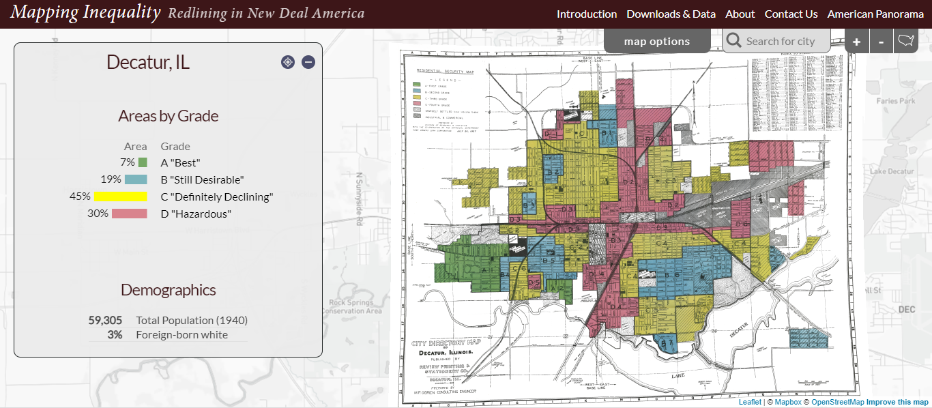

Significant analysis has been done to understand and diagnose these systemic housing challenges in Decatur, Illinois. The city has deployed several plans and studies including the Great Streets, Great Neighborhoods project along the Jasper Street Corridor; the Neighborhood Revitalization roadmap for the future in 2017; an Impediments to Fair Housing analysis completed in 2021; a Housing Market Analysis and Feasibility Study completed in 2021; Housing Strategy Recommendations presented in 2022; an equitable code enforcement assessment in 2022; and a Multifamily Residential Analysis completed in the summer of 2023. These documents describe a city with significant housing quality concerns; a limited supply of quality affordable rental units; a lack of credit and credit building opportunities for low-income residents; lack of sufficient income or access to equity for low-income homeowners to address housing repairs and rehabs; high rates of abandonment and vacancy; and low developer capacity for new multifamily residential.
Along with investing in studies and plans to help identify housing issues in Decatur, the city is actively working to mitigate these issues. The City of Decatur developed a Small Home Improvement Program in 2022, which is funded by American Rescue Plan dollars. The City partners with the Northeast Community Fund (NECF) in this effort to assist low-income homeowners with small home repairs. As of October 2023, NECF and the City have assisted 45 households from an original applicant list of 1,642 households across their two programs. The City has set aside a total of $4.4 million in ARP dollars to fund these programs through 2024. The city also joined the Central Illinois Land Bank Authority in 2021 to build additional capacity to address the housing barriers at the city, especially the issue of addressing abandonment, vacancy, and substandard housing. Together they have expanded the city’s existing roof repair and replacement program for low-income homeowners and created our new Abandonment to Rehab program. As of October 2023, the roof program continues to work through a waitlist of 285 households. So far, 20 have been successfully income qualified, 10 RFPs have been issued, and 5 have been successfully awarded a bid. This work has all been funded by the Illinois Housing and Development Agency and American Rescue Plan dollars.
The Abandonment to Rehab Program was developed in 2022 as one tool for stopping cycles of disrepair and increasing access to homeownership for low-to-moderate first-time homebuyers. The program identifies abandoned properties that can be saved, rehabs the homes to code standards, and sells to first time homebuyers. The goal of the program is to reenter properties onto the tax rolls that may likely have become demolition candidates if there was no intervention. The program also works to strengthen neighborhoods one block at a time with strategic rehabs, as well as provide homeownership opportunities for low-and moderate-income residents that are often cost-burdened as renters in the city. According to the recent Housing Market and Real Estate Feasibility Analysis from Teska Associates, 42% of the City’s renters face rent burden, far higher than the state average. Some of the same households paying high rent could have lower monthly payment and own a home with this program.
Along with the city’s repair and rehabilitation programs, the city has also developed a list of 182 properties in need of demolition. Since 2020, the city has worked with local contractors to demolish around 300 homes that are unsafe and unfit for rehabilitation. This past year, the city spent $3.5 million on demolitions and has budgeted an additional $3 million for next year. Additionally, starting in 2022, the city developed a mapping and web platform to assist in decision making and to make funding dispersion more transparent in their neighborhood revitalization efforts. Decatur is deeply invested in creating transparent and equitable processes and plans to address their core housing and community development needs.

Affordable Housing Demand and Needs (13 points)

Decatur struggles with an affordable housing crisis not often addressed or focused on by state and federal policy. The issue here is not one of a tight market – Decatur’s experiences differ greatly when compared to the US coastal cities and regions that often shape federal housing policy. Instead, Decatur struggles significantly with affordable housing quality. The city might have an abundance of housing stock that is affordable for a range of income limits, but the quality is far from accessible or healthy. Furthermore, with the continued cycles of disrepair and inevitable demolitions, the city is losing housing and will continue to lose housing at a faster rate if there aren’t significant interventions. Despite the efforts of the City of Decatur to address housing barriers over the past several years, the City still identifies the following as major housing needs: 1) low-income residents, especially those at 50% of AMI, need better access to healthy and stable housing; 2) homeowners still need help accessing financial resources for necessary repairs; and 3) the city needs more quality multifamily rental units.
Although housing stock tends to be naturally affordable in Decatur, 42% of renters in Decatur continue to experience rent burden. Those rates rise significantly when looking at low-income renters. Sixty-five percent of renters making between $20,000 and $34,999 are cost burdened and 95% of those making less than $20,000 are cost burdened. Although Housing Choice Vouchers are an option for very low-income renters in Decatur, those who receive a voucher face limited housing stock that does not meet their needs or the requirements of the Housing Authority. Along with limited housing options, it is difficult to find willing landlords with units that will pass inspections and meet affordability requirements. This creates an even more difficult rental environment for our low-income residents in Decatur.
Along with being financially cost-burdened, Decatur renters are also health burdened by rental housing stock as the city’s lower-income residents are more likely to deal with health and safety hazards in their housing. The Robert Wood Johnson County Health rankings lists Macon County, of which Decatur is the county seat, as one of the least healthy counties in the state and the Illinois Department of Public Health identifies 7 zip codes in Macon County as having a high risk of lead poisoning. The entirety of the City of Decatur is high risk (see Figure 2). Risk factors for lead poisoning can include concentrated populations under the age of 5 years old, lower socio-economic status, and housing built before 1979. Every one of the 7 at risk zip codes has more than 65% of its housing stock built before 1979. Furthermore, the vast majority, 83%, of Macon County’s children under the age of 5 years old are concentrated in these high-risk zip codes. Poor housing conditions in City of Decatur pose a direct threat the health and safety of the residents of Macon County and Decatur, especially children in rental housing. Although the increased stability of affordable homeownership may be an option for low-income households in Decatur, homes for purchase at their level of affordability (approximately $60,000) will very likely have deferred maintenance and repair costs. Housing plays a crucial role in creating and supporting healthy households. With an aging and deteriorating housing stock and high risks for lead poisoning, it is essential to address the health of residents in Decatur through housing rehabilitation and repair.
Although housing rehabilitation and repair is a necessary intervention in Decatur, homeowners and landlords struggle to keep up with repair needs for several reasons. Many homes need costly repairs, but owners are not guaranteed a return on that investment and banks are hesitant to provide loans due to the low value of homes since repair and rehabilitation needs are often more expensive than the value of the home itself. Unfortunately, deferred maintenance only gets more costly over time and contributes to the continuing blight in Decatur.

Figure 1: Macon County High Risk Zip Codes (The entirety of Decatur is high risk)
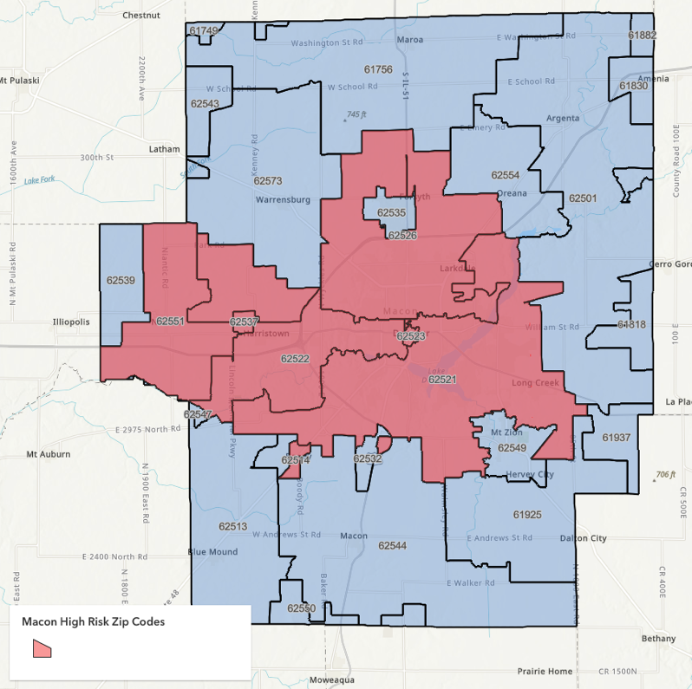
[ADD CITY SHAPEFILE]

Persistent Barriers to Equitable and Accessible Affordable Housing (10 points)

The key barriers to producing and preserving affordable and accessible housing in Decatur boils down to persistent cycles of disrepair and disinvestment in a city with insufficient resources to tackle the issues at scale. In order to effectively address affordable housing needs in Decatur, the city needs to 1) identify sustainable funding sources; 2) develop holistic housing related programming that is deployed block to block; 3) identify partners to build continuums of support for homeowners and renters; and 4) build non-profit developer capacity. As it stands, the tools simply do not exist to fit the needs of legacy communities in the Midwest.
There is significant work to be done to increase housing-based health, opportunity, and stability for Decatur’s low-income residents and typical growth-oriented housing tools and policies simply do not work. LIHTC, the most common housing tool for affordable housing development, are incredibly important but the projects are often expensive and there is never enough funding or allocations to meet the demands across Illinois. In many hot market cities, the Total Development Cost on LIHTC new construction projects is often $400k+ per unit. While Decatur needs more quality affordable housing units and LIHTC projects, it’s important to ask whether this tool effectively addresses the staggering number of vacant housing units in Decatur. Realistically speaking, 4% LIHTC projects do not pencil out economically outside of hot market environments and this means there is no real tool to encourage rehab and repair investment at scale in places like Decatur. Even if LIHTC projects were an achievable reality in Decatur, they are increasingly competitive and associated developer fees rarely stay in the region. The lack of tools to address housing issues in legacy cities is a significant problem and a gap in state and federal housing plans that should be addressed.
At a state level, there are funds available through the Illinois Housing and Development Agency to help repair and rehab homes, but these homes often need subsidies that far outweigh allowable project costs. For example, in the IHDA Strong Communities Program rehabs are capped at $40,000. From our practice so far, the dollars needed for homeowner occupied repairs average at about $60,000 - 70,000 while full rehabs of abandoned homes require usually $100,000 - $150,000 to bring the home up to code compliance. As an example of the need for deep subsidies, our 1st Abandonment to Rehab project RFP at 439 S Maffit Street was contracted for $100,000 and will sell for $50,000. To stretch these funds, the land bank aims to control program subsidy at $50,000 maximum per project. This means that to operate our programs at scale, we need sustainable funds to bring homes up to code, stop deterioration, and improve access to healthy and safe housing in Decatur. Although these repairs and rehabs require significant dollars, it is a much more efficient use of money when compared to LIHTC or new construction or compared to the millions of dollars needed for demolition if cycles of disrepair are not addressed. Unfortunately, without significant investment from the public and private sectors, rehabs at scale will be unattainable and the number of vacant units in Decatur will only grow - worsening blight overtime. The cost of inaction only grows as we collectively kick the can down the road.

Exhibit D: Soundness of Approach (35 points total)

Vision (20 points – includes the next four sections)

Our goal with PRO Housing dollars is to turn plans into equitable and sustainable action. Focusing on the City of Decatur, we aim to use these funds to build opportunity in places historically disinvested and enhance access in higher opportunity areas. Over the next five years, we will expand our Abandonment to Rehab (A2R) program and disrupt cycles of disrepair at the block level by building continuums of support surrounding A2R sites.
First and foremost, we will fund our new Abandonment to Rehab program to increase access to affordable homeownership for low-to-moderate income households. Since 2021, The City of Decatur has been working with the Central Illinois Land Bank Authority (CILBA) to address our large-scale housing challenges. This work has resulted in program development spanning lead abatement of rental properties, rehabilitation, and repair of owner-occupied homes, and A2R which that turns abandoned properties into first time homebuying opportunities. So far we have finished one full rehab and have four additional contracts underway. These five projects have completely expended our current ARP allocations. With our requested PRO Housing funds, we will rehab and sell 36 homes to low-income first-time homebuyers transitioning this program from a pilot to a fully scaled-up program.

Building Holistic Programming

We acknowledge that homeownership is not and should not be the only option for low-income households to exit high-cost burden and unhealthy, unstable living situations. Additionally, we know that our Abandonment to Rehab initiative cannot singularly tackle the vacancy and substandard housing issues in Decatur. Therefore, we believe in developing and implementing holistic housing programs that 1) help renters become successful homebuyers, 2) expand access to repair and rehab funds for homeowners, and 3) mitigate lead and other health and safety hazards in rental units. There also needs to be significant collaboration and strategic planning with state and local organizations, departments, and officials to expand the pool of affordable housing developers and property managers in the area. As of now, there is a significant dearth of developers, non-profits, and other partners to handle the development and successful management of affordable rentals. We believe that by supporting our new initiatives and building an ecosystem of continued support, we will begin to see additional investment in the future.

Our Approach – Analysis and Development Plan

Although the main function of this grant request is to support Decatur’s new Abandonment to Rehab program, we are requesting additional funds to build a block-by-block reinvestment strategy rooted in building opportunity with intentionality, care, and strategic investment. Our goal with our Abandonment to Rehab program is to target consolidated rehabs to improve entire blocks for a larger impact rather than piece meal rehabs. Along with consolidating these repair and rehabs for homebuyers, we will also look at the block holistically and work to provide all residents of the block the appropriate tools and resources to improve their experiences and living conditions. The goal is to build opportunity for homeownership and improve the neighborhoods at scale without displacement. This will require targeting resources for many households on the street, not just the new homeowners.
This approach includes building an effective tool to guide decision making around how to target investment, developing a suite of programs necessary to uplift housing block-by-block, funds to support these new and existing supportive programs, identifying partners and opportunities, and developing supporting materials for future relationship building and funding applications. Although much of this work will be done in house, we will lean on the support of the Central Illinois Land Bank Authority and the Illinois Housing Lab to expend these grant dollars.
The additional requested PRO housing funds beyond A2R will be used to subcontract analysis and program development from the Illinois Housing Lab (IHL), a lab at the University of Illinois at Urbana Champaign dedicated to producing policy informed research related to housing throughout the United States. Over the first year and a half of the grant, IHL will develop an equity-based evaluation and measurement tool to identify targeted neighborhoods for A2R projects and continuums of support. Using this new tool, IHL will work in partnership with Decatur to select neighborhoods that will receive targeted reinvestment through A2R and additional needed continuums of support. IHL will then engage in a small area assessment of these targeted neighborhoods to understand the block level housing needs surrounding A2R sites. Once the assessment has been complete, the lab will work to fully develop the suite of tools and programs needed to address housing concerns surrounding the A2R site. These tools and programs will likely cover 1) credit building, repair, and housing counseling; 2) supporting responsible landlords with repairs and creating a new pipeline of HCV properties; and 3) building partnerships and filling organizational gaps to plan for mission-based new development.

Possible Additional Tools and Programs

Our Abandonment to Rehab initiative will likely include collaborations with local banks and organizations to make sure we are helping first time homebuyers build the foundational tools necessary for success. The proposed initiative will also provide banks with the opportunity to meet CRA goals by doing the following: 1) provide credit building/repair to interested first time homebuyers, 2) provide financial coaching to track clients over time, and 3) provide state and federally approved lending products. If the local banks are doing credit building repair and financial coaching, then local organizations can focus on taking referrals from banks and provide homeownership counseling.
Given the significant age and deterioration of housing in Decatur, we will also look towards building capacity and scale of our existing homeowner occupied repair and rehab program while also creating a new pool of funding to work with local landlords to improve health and safety conditions of rental properties. Together, we will expand existing repair programs to include a targeted approach surrounding A2R sites and identify aging rental housing to improve the condition of those rental properties while maintaining affordability for their current tenants. These programs will include income limits and affordability requirements.
The City of Decatur and its downstate partners are working tirelessly to combat severe vacancy, abandonment, and substandard housing through various initiatives and programs. At this moment, CILBA sees a great opportunity for partnerships with the Central Illinois Land Bank Authority, the Illinois Housing Lab, and state and federal programs to pilot new housing tools for downstate communities that can be replicated elsewhere. If all of Decatur’s 5,000 vacant units became future demolitions, it would cost $75 million. We believe the state and the nation would much prefer funding rehabs that keep buildings on the tax rolls than invest in demolitions in the tens of millions range. PRO Housing funds will help to support our new Abandonment to Rehab project as well as our additional programs and initiatives that help to improve housing stock and living conditions in the city.

Engagement Plan (5 points)

Our plan is to engage with residents, various organizations (social service provides, housing providers, developers, etc), and landlords through various engagement methods. Most of the engagement will take place while Illinois Housing Lab is developing their selection tool and developing programs to assist with the targeted investment approach. We foresee individual interviews, focus groups, and open houses. We also intend to develop a public facing website that will highlight where were are investing dollars, why and how those neighborhoods are chosen, and the details of the investment. Our goal is to provide full transparency to the public and provide opportunities for the public to comment and assist in the shaping of the additional housing tools developed using these funds.

Affirmatively Furthering Fair Housing (5 points)

Our proposal both affirms and pushes back on PRO Housing’s and HUD’s definition and approach to fair housing, as well as the determination of priority geographies. Whenever possible, our plans will focus on enhancing access to areas of high opportunity. We will take this into account when developing our tool for determining targeted neighborhoods for A2R and continuum of support programs. The tool will be guided by social equity standards and AFFH parameters. Along with this, we also acknowledge that solely moving households to areas of high opportunity would result in the continued exodus of households from the urban core to peripheral communities and lead to ongoing sprawl. Areas of high opportunity are defined as “Difficult Development Areas” (DDAs) or areas where poverty rates fall below 10% in metropolitan areas. In the Decatur metro area, HUD has only identified a peripheral suburb, Forsyth, as a DDA (see Figure 4 in red). This area is not in our geographic scope and, if it were, would likely put our residents further away from services and support networks. This criterion is also replicated by the Illinois Housing Development Authority’s designation of “Opportunity Areas” which are used as scoring mechanisms of Qualified Action Plans for receiving LIHTC. The most up to date “Opportunity Areas” in the Decatur area can be seen in Figure 5 in dark blue. This again designates the Forsyth areas as an identified focus area. Furthermore, when broadly analyzing neighborhoods with low poverty rates in Decatur and internally identifying them as higher opportunity areas in the city (although not officially designated as such by HUD or IHDA), these areas again occur all along the peripheral boundaries of Decatur (see Figure 5). This designation of “Difficult to Develop Areas” is inherently tied to the idea of valuing recipient areas of white flight as more valuable and that simply moving people to census tracts with low poverty rates as the cure to our issues. If we were to solely follow this logic in Decatur, we would likely move people further away from services and social support networks and continue to contribute to ongoing sprawl. We actively call for a two pronged that not only increased access to higher opportunity areas, but prioritizes building opportunities in neighborhoods that have been historically disinvested. We see these places are being “Difficult to Develop Areas”, but perhaps of a different kind - areas that are difficult to develop should include geographies that are so severely disinvested that significant public subsidy is required in order to support households and preserve housing. These are areas where deep subsidies are needed for intentional and caring strategic investment.
We also call attention to the inherent growth-oriented biases in PRO Housing’s priority geography measurements. Focusing predominantly on numbers of affordable housing not keeping up with population change gives tight markets an advantage in scoring. We believe the measurements should include a broader interpretation of “affordable housing crisis” to include areas where access to quality affordable housing is shrinking due to widespread disinvestment and disrepair.

Figure 4: HUD Designated Difficult Development Areas
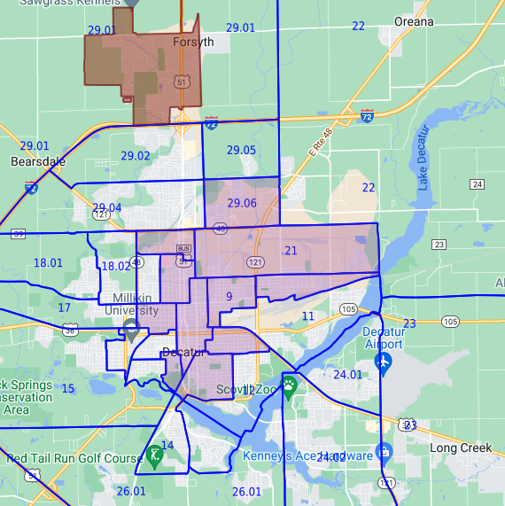

Figure 5: Opportunity Areas, Illinois Housing Development Authority 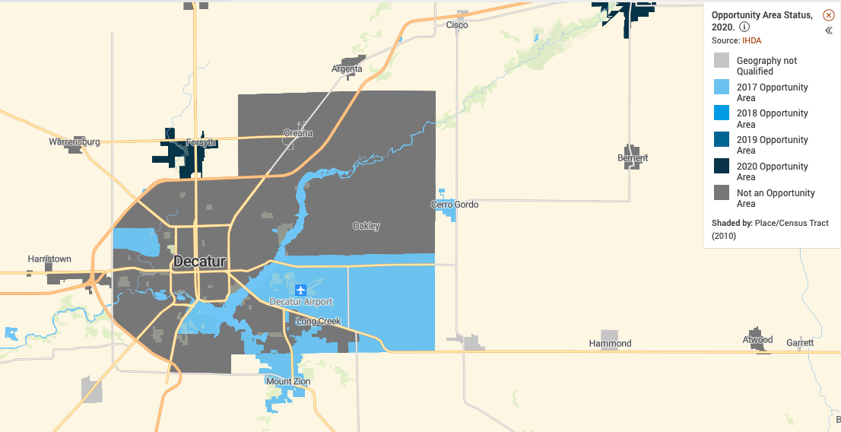

Figure 5: Poverty Rates in Decatur by Census Tract
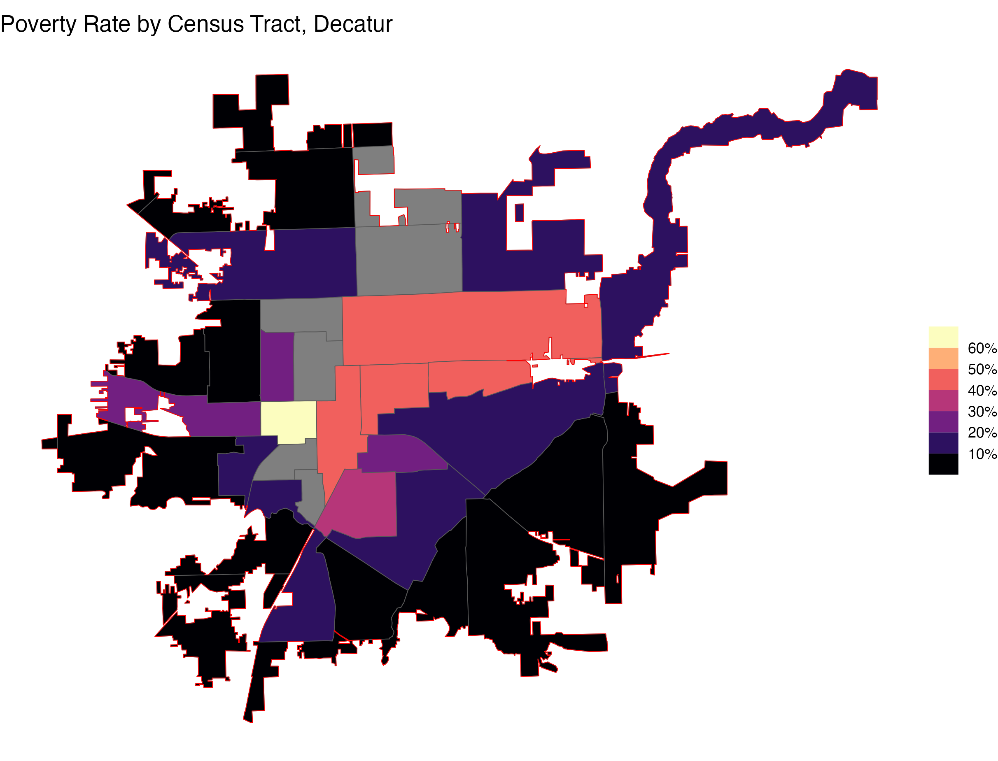
We believe that although Decatur is not considered a priority geography nor does the city have HUD or state designated “Difficult to Develop Areas” or “Opportunity Areas”, that it is a city in desperate need of public financial intervention in order to rectify historical segregatory practices. As we mentioned earlier, more than 75% of the city was redlined (all of the urban core) resulting in restricted access to equity building for our black and brown residents.
Our programs will also center increasing access to credit building and repair services and access to loans for those who have been historically denied in geographies that were redlined.

Budget and Timeline (5 points)

We are requesting $10 million dollars to support our proposed plan to expand our Abandonment to Rehab in a targeted approach with paired continuum of support programming. This budget includes $5.3 million for rehabilitating 36 abandoned homes, $3.8 million to support targeted repairs and rehabs surrounding A2R sites, $200,000 for consultant analysis and program development work through the Illinois Housing Lab, and $700,000 general administrative dollars to support additional City of Decatur/CILBA staff time to oversee and assist the new programming made possible by this grant. We are leveraging an addition $7 million of ARPA, state grant funds, and CDBG/HOME dollars to support this work in 2024. We expect continued contributions in future years.
Our proposed timeline focuses on 1.5 years of analysis, capacity building, public engagement, and program development with the Illinois Housing Lab starting in January 2024. Although some rehab and repair work will begin in that same time period, a majority of the implementation will take place from 2025 to 2029. We expect to full expend PRO Housing funds by the end of August 2029. See Figure 6 below for more detail.

Figure 6: Grant Timeline
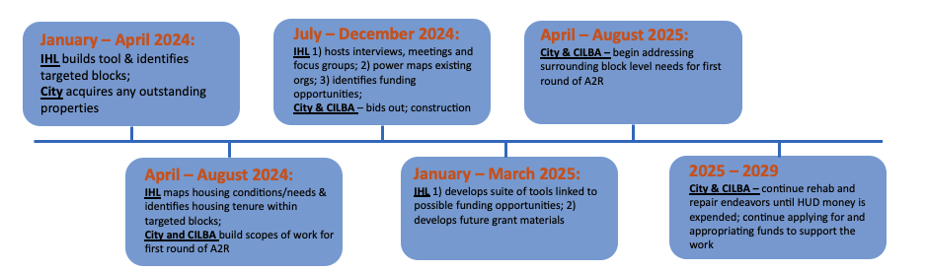

Exhibit E: Capacity

- What capacity do you and your Partner(s) have? What is your staffing plan?

Our approach to housing rehab work is to preserve affordable housing, to improve the health and safety of our housing stock, and to keep residents housed. Rehabilitation and repair of existing housing stock is key to extending the life of a housing unit and in revitalizing many of our neighborhoods. If we do not address our aging and deteriorating housing stock, then we will expend a considerable amount of money demolishing homes and maintaining a growing number of vacant lots. This drives our continued work in providing CDBG and HOME Residential Rehabilitation Programs, acquiring additional grants like HUD PRO Housing, utilizing ARP dollars to expand our capacity, and partnering with organizations and institutions like CILBA and the Illinois Housing Lab at the University of Illinois. Through these multiple streams of funding and strategic partnerships, we are increasing our capacity and number of households served. The need for this programming is clear – in October 2019, our Residential Rehabilitation Program lottery was opened for just over a month. We saw approximately 400 households apply for assistance.
This clear need is why we are partnering with the Central Illinois Land Bank Authority and IHL. CILBA will assist us grant administration and oversight and program execution of our Abandonment to Rehab program. CILBA has been a partner to the city since its inception and has worked tirelessly with us to build capacity and develop new programs to tackle vacancy, abandonment, and substandard housing. We are excited to have them as a partner in this work. Illinois Housing Lab, a newer partnership, will provide at least one 50% FTE research assistant and two 25% FTE research assistants to provide the frontloaded analysis and program development work. This will be overseen by the lab’s director, Dr. Andrew Greenlee, who will provide 12.5% FTE for supervisory work.
The requested 10% general administrative fees from PRO Housing will help to cover an additional 1.5 FTE staff hire for CILBA to help oversee the administration of this grant and the expansion of repair and rehab programming under this grant.

Exhibit F: Leverage

In total, we have leveraged an additional $7 million for this holistic approach to preserving and creating affordable housing opportunities in Decatur. This leveraged or matched funds include $1.8 million in resell values for Abandonment to Rehab properties. We expect each A2R property to sell for about $50,000 and these dollars will go right back into funding the program. We have also recently acquired a $337,000 state grant from IHDA and the city has dedicated $500,000 of ARP funds towards the Abandonment to Rehab program. The ARP dollars were dedicated and expended in 2023 to help build a pipeline of abandoned to rehab properties and begin rehabs. The IHDA funds will be expended late 2023 through 2024. Additionally, the city has dedicated another $4.5 million in ARP funds for homeowner occupied repair and rehabs for 2024.

Exhibit G: Long-Term Effect

Effects of these investments will certainly be felt in the short term as first-time low-income homebuyers access affordable homeownership and current homeowners access repair and rehab dollars. We expect that homeowners will quickly feel the stability of homeownership and the improvement of housing quality and health within the term the grant. In the long-term, looking beyond the terms of the HUD PRO Housing grant, we hope to see continued positive reinvestment in urban core neighborhoods that have been disinvested due to population loss and historical redlining. With a continued presence of public dollar investment, we hope to see households building equity and maintaining health at a neighborhood scale.
Additionally, we see this grant opportunity as dedicated time, space and resources to build the necessary partnerships to do this work at scale for years to come. Through work with Illinois Housing Lab and CILBA we hope to build a solidified suite of tools to address affordable housing issues in Decatur, understand existing partners and their capacity in Decatur, and begin to build the network necessary to consider the possibility of new construction.

Housing Market and Real Estate Feasibility. 2021. Teska & Associates
US Census Bureau (2020). Selected Housing Characteristics, Table DP04, 2016-2020.
Teska Associates, Inc. Analysis of Impediments to Fair Housing Choice. December 7, 2021.
Teska Associates, Inc. Analysis of Impediments to Fair Housing Choice. December 7, 2021.
Robert Wood Johnson County Health Rankings, Macon County IL https://www.countyhealthrankings.org/app/illinois/2022/rankings/macon/county/outcomes/overall/snapshot
Illinois Department of Public Health, Childhood Lead Poisoning Surveillance https://dph.illinois.gov/topics-services/environmental-health-protection/lead-poisoning-prevention/childhood-surveillance.html
Mayans, Laura. (2019). Lead Poisoning in Children. American Family Physician. https://www.aafp.org/pubs/afp/issues/2019/0701/p24.html
US Census. Age and Sex, Table S0101, 2016-2020.
Teska Associates, Inc. CILBA Housing Market Analysis and Feasibility Study. December 2021.
Teska Associates, Inc. CILBA Housing Market Analysis and Feasibility Study. December 2021.
FHFA. Overview of the 2020 High Opportunity Areas File. https://www.fhfa.gov/DataTools/Downloads/Documents/Enterprise-PUDB/DTS_Residential-Economic-Diversity-Areas/DTS_High%20Opportunity_Areas_2020_README.pdf
https://www.ihda.org/developers/market-research/opportunity-areas/

