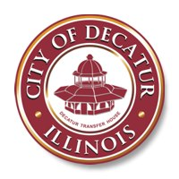
CITY OF DECATUR ILLINOIS
#1 GARY K. ANDERSON PLAZA DECATUR, ILLINOIS 62523-1196

FOR IMMEDIATE RELEASE
July 7, 2022

An update on new ambulance services for Decatur

Decatur, IL – The ambulance working group met again this week to discuss developments in the search for new ambulance services for Decatur and Macon County.
The “invitation to submit proposals” sent out last week was well-received and a number of private companies expressed interest in serving our area. The group discussed which companies they heard back from and what additional information can be provided to aid those companies in putting together their respective formal proposals.
“It was another productive meeting for the group and we look forward to further discussions with interested ambulance companies,” said Deputy City Manager Jon Kindseth. “We are all working quickly to encourage as many companies as possible respond to this invitation to serve as our community’s emergency EMS service.”
There are a lot of factors for interested companies to consider, but the group has the expertise and means to provide the right information. The goal is to make the transition as smooth as possible and to ensure no service interruption for the citizens of Decatur & Macon County.
The group is continuing to keep our many first responder and medical provider partners involved or informed throughout this process. During discussions the group has talked about staffing and continues to encourage new companies consider extending employment opportunities to current DAS staff.
Proposals are starting to come in from interested companies. The group will continue to review them and discuss if they are the right fit for our community.
The ambulance working group will meet again next week and we will keep the community updated when additional information becomes available.

###

